

**Caregiver**

**Virtual Timecard**

**INSTRUCTIONS**



**Login & Passcodes**

To start your Virtual Electronic Timecard follow these steps

1. Go to: <https://marsprg.com/crossroads>
2. Enter your User Name and Passcode as indicated below

USERNAME: ________________(first name & last name, NO spaces, Lower case)

PASSCODE: _________________ (use “Time4Fun” – Change your passcode and record it so

you do not forget it)

You should now have the below screen:

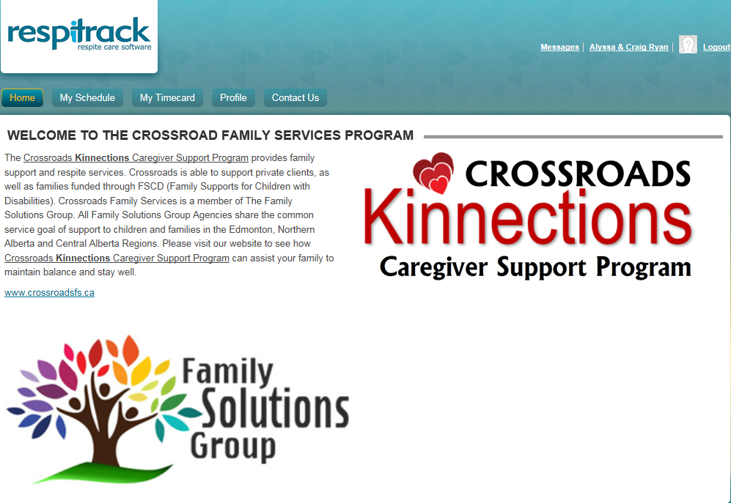



**TAB OPTIONS**

**HOME:** This is the main screen that you see each time that you sign into the program

**MY SCHEDULE:**

This tab is where you will spend most of your time. It give’s you the option for **“My Calendar”** or **“My Appointments”**

**MY CALENDAR:** This gives you a calendar to see all booked appointments (Approved Appointments )that have been assigned to you. It can be sorted by day, week, month, or specified time period.

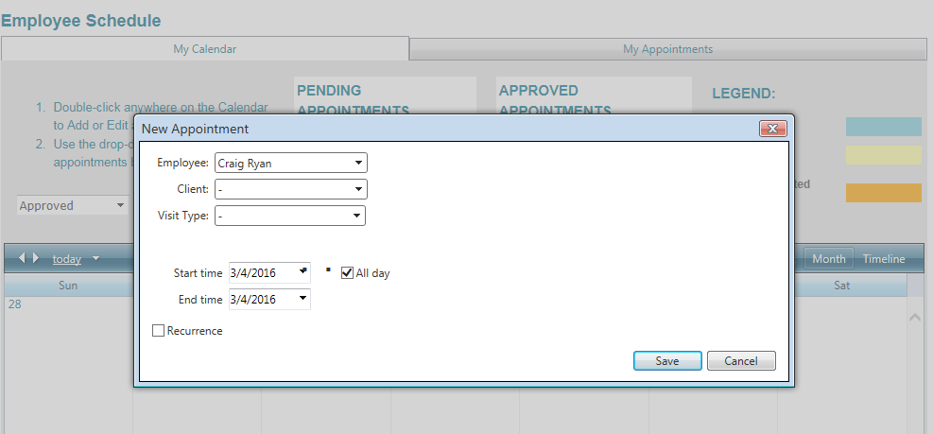If your client requests to book an appointment with you, you can double click on the calendar for the day of the week they are requesting service for, and fill in the information of their request.

1. Select your name
2. Select Client
3. Select Visit Type

See attached list of types of

visits

1. Un Check the “All DAY”

Box and indicate the

“Start and End” times

being requested.

1. Click “SAVE”

This appointment will be assigned as “PENDING” until Crossroads Admin approve the appointment.

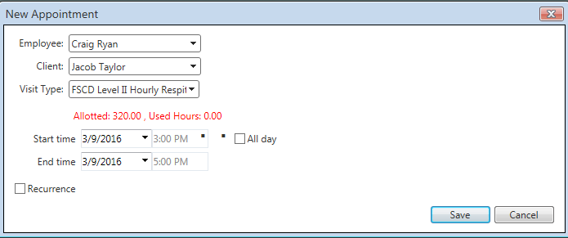EXAMPLE



**MY APPOINTMENTS:** This is where you can review all of the appointments you have completed.

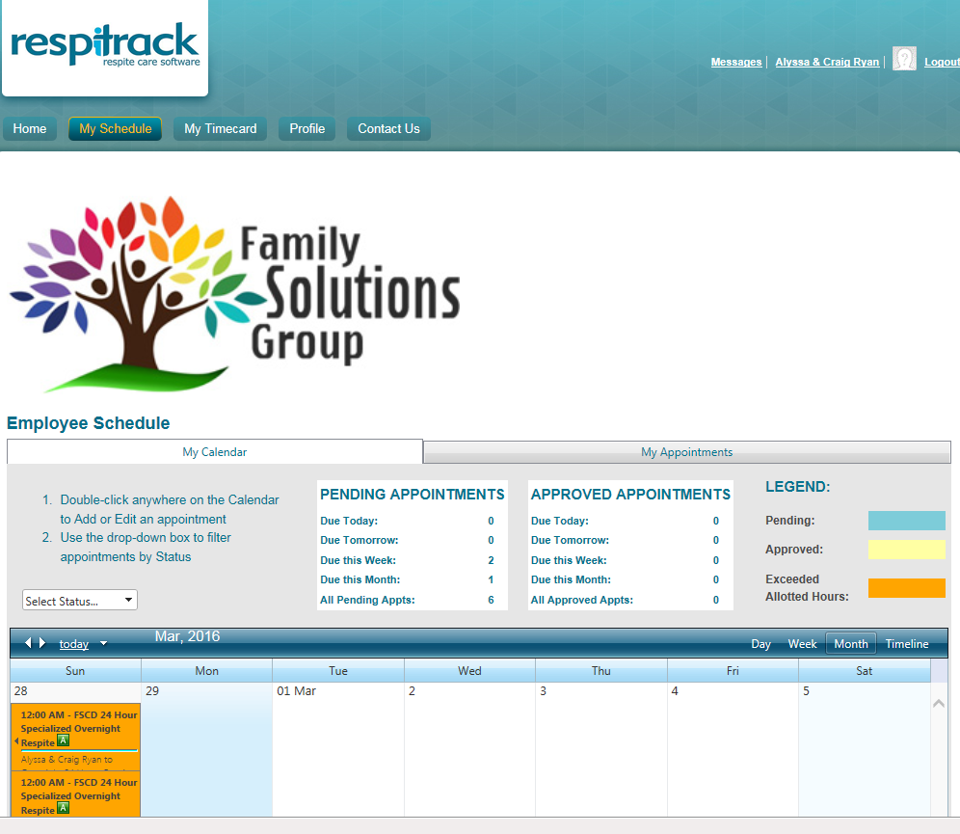

**MY CALENDAR**

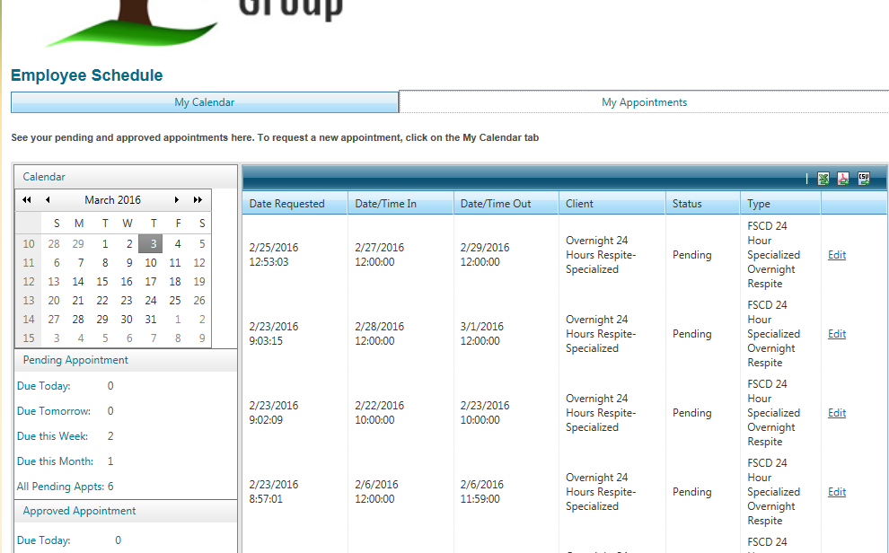

**MY APPOINTMENTS**



**MY TIMECARD**

This is where you will be doing your Electronic Virtual Timesheet. Below is an example of the screen along with the steps you take to add your work completed to your timecard:

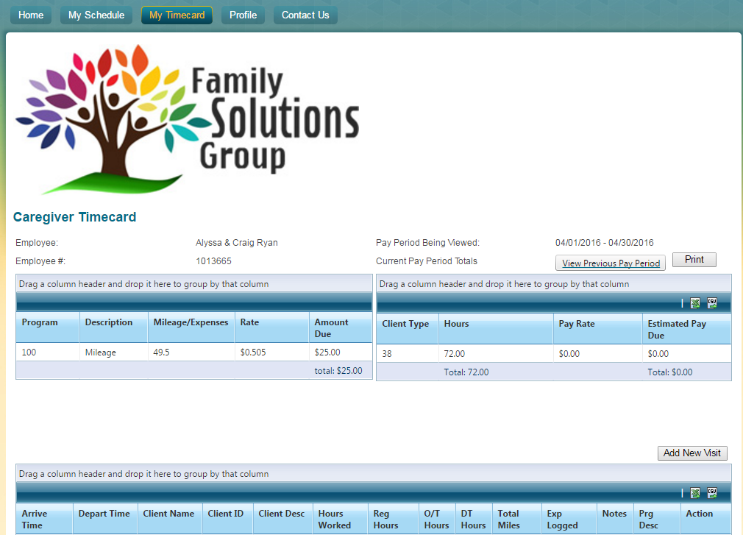

1. First - To record appointments to your timecard card make sure you are on the correct pay period.

2. Once the pay period you are recording for appears, click the add new visit button.

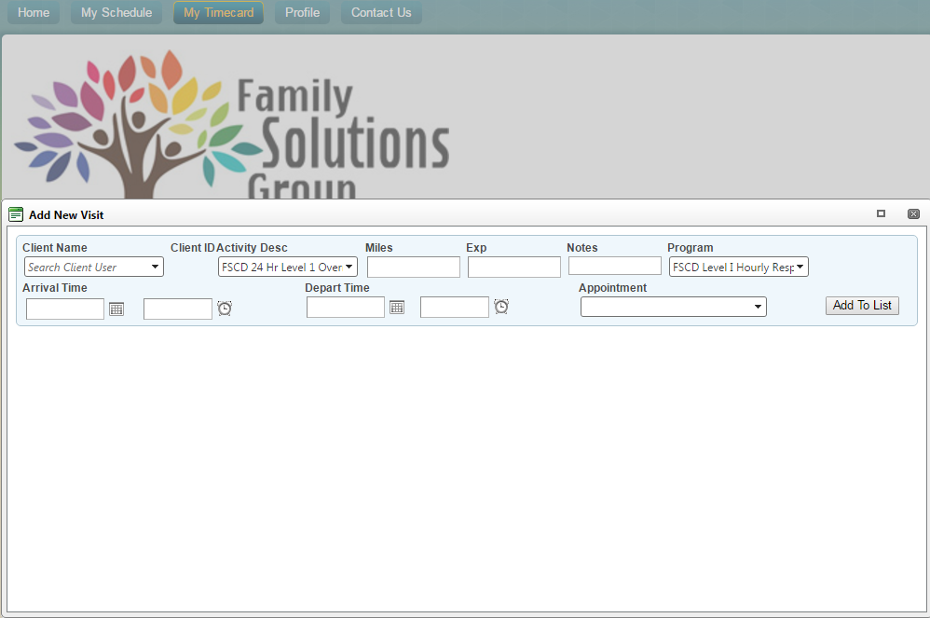3. You are now to record your appointment information:

* Client Name is Alphabetical by first name

* Make sure you choose the correct Client Activity Code, Miles records as KM (The correct Code will be on the approved appointment on your calendar)

* Arrival time is your start time in AM/PM. Clicking the clock will bring you down a select time list

* Depart Time is your end time for the appointment. Again specify AM/PM

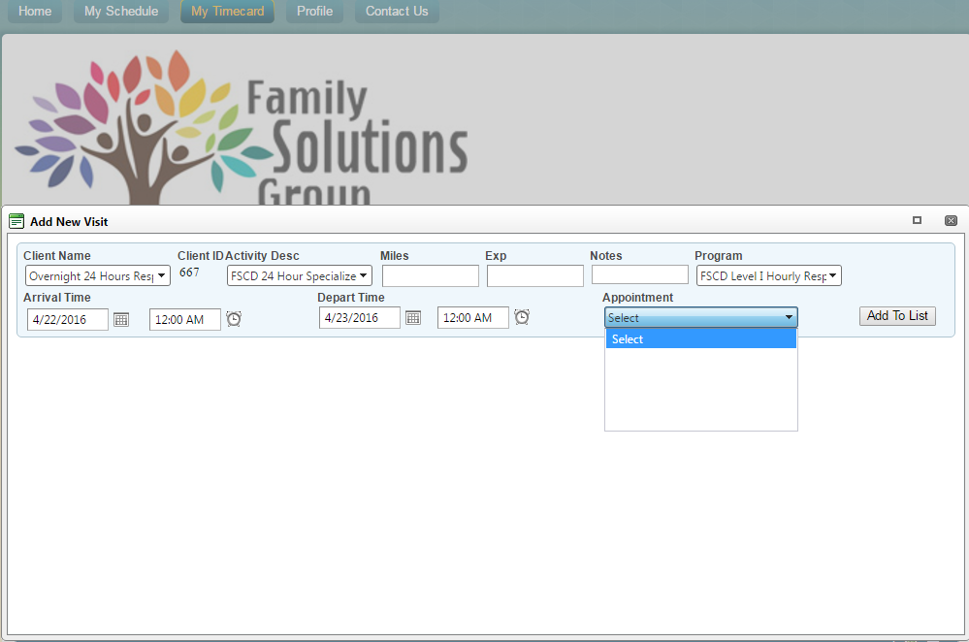

* Your appointment should be listed in the drop down box “Appointment”. Select the date that you are recording and then click the “Add to List Button

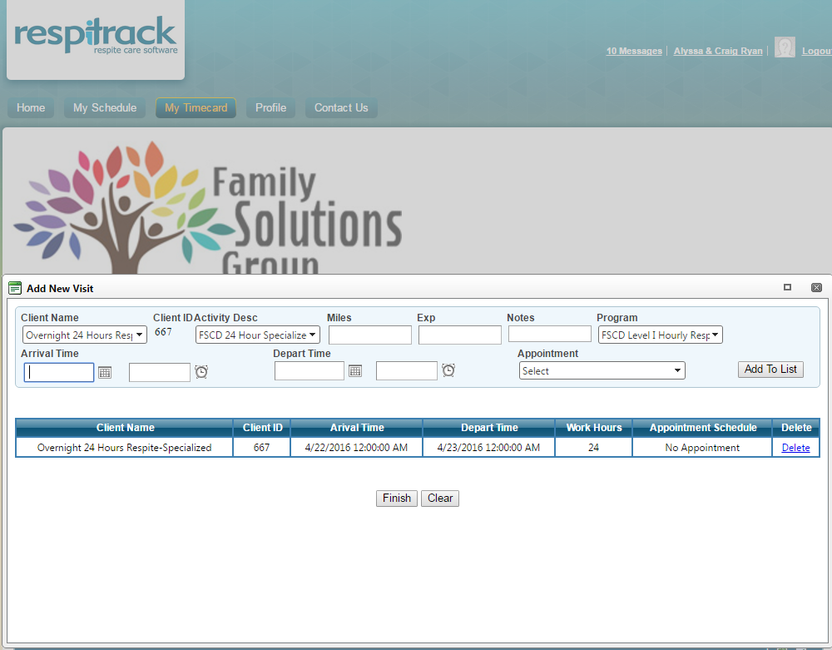

**Your appointment should be shown in the body now. If you have more appointments to record restart these above steps.**

**Once All appointments are entered, click the finish button**

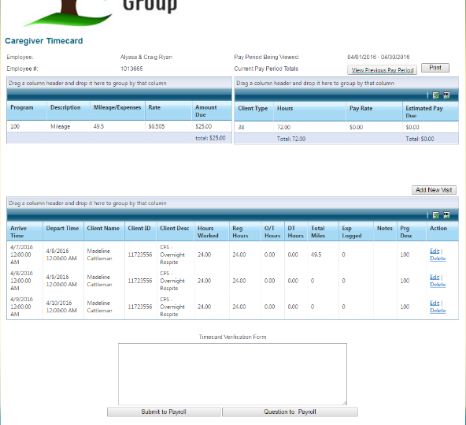

**You should now have this screen that shows all of the appointments you keyed in.**

**If it is the end of the month and you are ready to submit your timesheet after all appointments are recorded, simply click this button.**



**NOTES:**

**RURAL ROUND TRIP TRAVEL**

If you have Rural Round Trip Travel approved for a child, you will need to key the information as a 1-hour block in advance of your appointment time.

**Example:**

The Appointment for client is from 6:00 pm to 9:00 pm, but you have approval for paid mileage and travel. Add a appointment from 5:00 pm to 6:00 pm choosing the rate code that is specific to your client (sample wording: Henry Leung Rural Round Trip Travel) Note: If you have a sibling appointment that has approval for Rural Round Trip Travel, you must choose the rate code that states RATIO Rural Travel so that the system pro rates these costs.

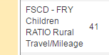

**SIBLING VISITS**

The Respitrack system has been set up to generate multiple invoices when sibling visits are completed. When keying your sibling visit into your virtual timecard you only key one child’s name from the sibling group, and then the rate code would be either FSCD ratio billing Level 1 or 2 (for up to 2 siblings), or FSCD-Hourly Respite Level 1 (or 2) Ratio Billing – More than 2 children.

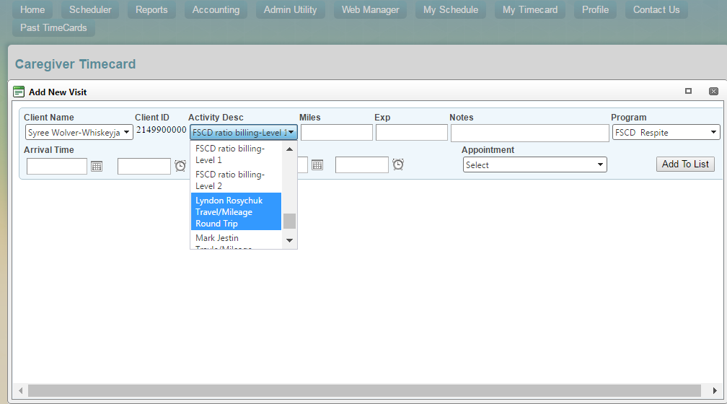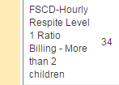



**COMMUNICATIONS**

At the top Right hand side of your screen you have a message box that advises you of any messages you have received. These messages include notifications for “Approved” appointments.

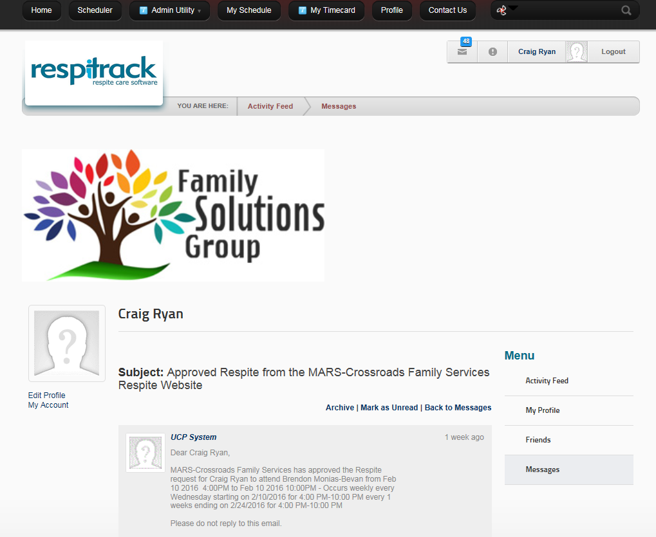



**PROFILE**

This tab is where you can view all of your personal information with Crossroads. Should you require any changes to this information, please contact Barb or Kayla at any time.

It also has a summary all of your communications (both sent and received) and, allows you to easily read through messages you have received. Once read you should click the ARCHIVE” button so that when you go into your messages, you are not having to go through a bunch of old notifications.

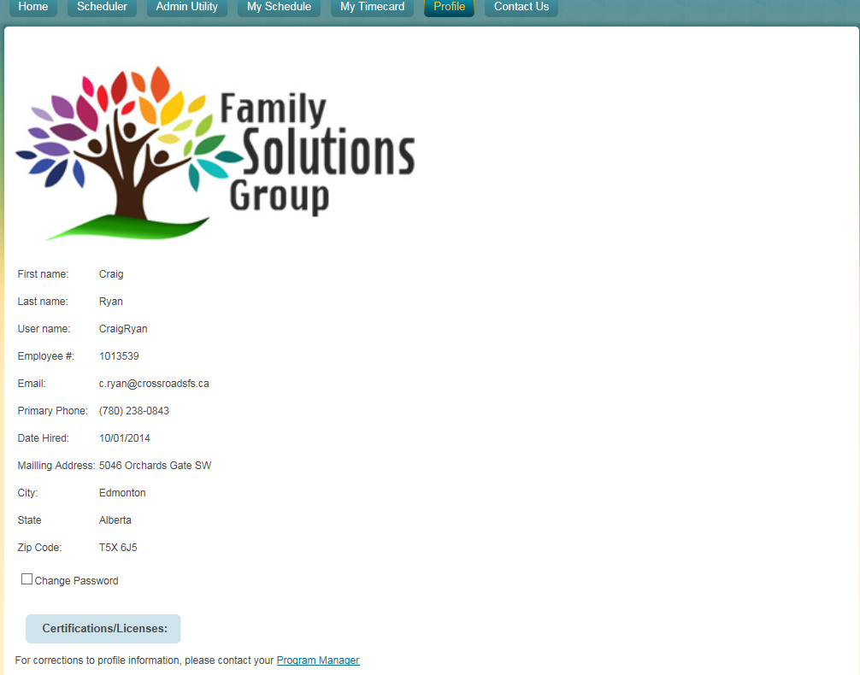

**Your Profile Information**

**YOUR MESSAGES**

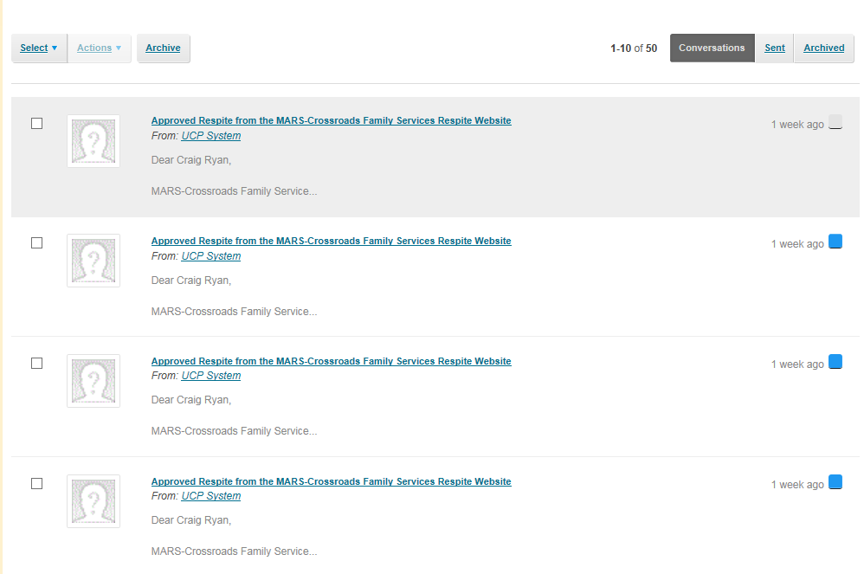



**CONTACT US**

This tab provides you with a list of all of your Crossroads Contacts



