 **Foster Parent Resources**

**Contents**

THE CHILD & YOUTH ADVOCATE 3

Young People Have Rights! 3

SAFE SLEEP FOR BABIES 4

CAR SEAT SAFETY 5

Rear Facing 5

Locking & Tether Clips 6

Forward Facing 7

Booster Seats 8

BED BUG OVERVIEW 9

Preparation For Home/Apartment Treatment Of Bed Bugs 10

Bed Bug Treatment Follow-Up And Clean-Up Guidelines 10

Recognizing a Bed Bug 11

How They Feed and Live 11

The Health Effects of Bed Bugs 12

Bed Bug Prevention 12

Be careful about what you bring into your house or buy 12

Key Messages About Bed Bugs 12

Checking for Bed Bugs 13

Bedbugs - How do I get rid of them? 14

Physical control methods 15

Bedbugs - How do I make sure they don't come back? 17

HEAD LICE MANAGEMENT 19

How To Check For Head Lice 20

OPTION A:Treatment Products: Head Lice Shampoo or Cream Rinse 21

OPTION B: Wet Combing: Using a nit comb and regular hair conditioner 23

OPTION C: Head Lice Treatment Spray 25

Alternatives Not Recommended 26

Undesirable And Dangerous Methods – Do Not Use 26

When Treatment Doesn’t Work 26

CAC Study Notes 2015-2019 Edition

# THE CHILD & YOUTH ADVOCATE



## Young People Have Rights!

**The OCYA represents the rights, interests and viewpoints of young people receiving intervention services under the Child, Youth and Family Enhancement Act, the Protection of Sexually Exploited Children Act; or who are involved with the youth justice system.**

**What is an Advocate?** An Advocate is someone who will listen to your views, wishes and feelings. They are someone who will support you to have your say when decisions are being made about you. An Advocate strongly believes that children’s rights are important and will work hard to make sure that you know your rights and how they apply to your situation. If a young person is not able to make their views known, an Advocate will put forward a rights-based perspective.

**What is legal representation?** Do you have a court matter coming up that will determine where you will live and who you will live with? You have a right to have your opinion heard by the judge. A lawyer may be able to help you. Contact our office to speak with an intake worker if you would like more details.

**Who can I talk to?** Even if you are not sure who to ask for (or even if you're not sure you're calling the right place) – try us! One of our friendly intake workers will listen and will probably ask a few questions. Depending on your wants and needs, you may be assigned an Advocate or a Lawyer. If our office isn’t the right place for you, our intake workers can still help by providing other resources and people to talk to

If you have questions about your rights as a young person, need legal help, or need to speak out, we’re here for you. All calls to our office are important and we will return messages left on our voicemail as soon as possible during regular business hours.

Talk to Us:

Call: **(780) 422-6056** Fax: **(780) 422-3675**

Toll-free: **(800) 661-3446** or Email:[**ca.information@OCYA.alberta.ca**](mailto:ca.information@OCYA.alberta.ca)

Monday – Friday 8:15 am to 4:30 pm. Closed 12 – 1 pm.

#600, 9925 109 Street NW

Edmonton AB T5K 2J8

# SAFE SLEEP FOR BABIES

* 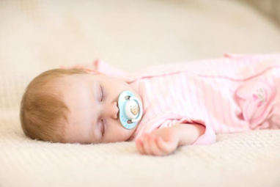**For the first year of life, the safest place for a baby to sleep is on her back for every sleep.** Babies sleeping on their back have a much lower risk of SIDS and choking. Around 6 months old, babies start to roll over on their own. Parents should continue to put baby on their back to sleep. It is okay if they change position on their own.
* **Babies need a firm, flat, uncluttered surface for sleeping to reduce the risks of SIDS, being trapped or smothering.** The safest place for a baby is a crib, cradle or bassinet that meets Canadian government safety standards. Cradles and bassinets have weight limits. Be sure to follow manufacturer’s guidelines. The crib should have a firm, flat mattress that is in good condition and fits snugly, a tight-fitting bottom sheet, slats that are not more than 6 cm (2 3/8 inches) apart, and a sticker indicating that it was made after September 1986. Baby’s crib should be free of soft materials like pillows, quilts, heavy blankets, toys or stuffed animals, bumper pads and positioning devices. These items are suffocation hazards. Car seats are designed to transport your baby safely in a motor vehicle. Child safety seats and infant carriers should not replace the crib for your baby’s sleep. When you get to where you are going take your baby out of the car seat for sleep.
* 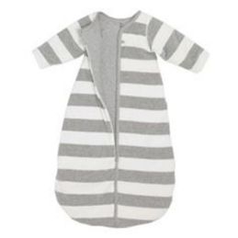**Keep a baby warm, not hot.** Room temperature should be comfortable for lightly clothed adults—about 20 to 22 C. Avoid covering babies head. Avoid heavy bedding. Overheating increases the risk of SIDS and babies can get trapped in loose bedding. A fitted one-piece sleeper reduces the need for additional blankets. If parents use a blanket, make sure it is lightweight, firmly tucked under the end of the mattress and reaches only to the baby’s chest. If parents use a sleep sack, make sure it fits properly around the arms, shoulders and chest so it doesn’t ride up around the baby’s neck and become a choking hazard.
* **Protect babies from second-hand smoke before and after birth.** Exposure to smoke greatly increases the risk of SIDS. No one should smoke around a baby at home, during travel, or with other caregivers. If a parent smokes encourage them to quit or cut back to quitting—both parent and baby would benefit.
* **Alberta Health Services, the Canadian Paediatric Society and the Public Health Agency of Canada recommend room-sharing until the infant is at least six months old.** Room-sharing means parents and baby share a room but each have their own sleep surface. Room-sharing allows for ease of feeding and increases opportunities to comfort the baby.
* **Room-sharing keeps your baby near without the risks of bed sharing**. Babies can die by being strangled or smothered if they get trapped in cracks or under bedding, pillows, cushions or another person. Bed-sharing is not advised by the Canadian Pediatric Society or Alberta Health Services. Having a baby’s crib next to the parent’s bed can help parents learn and respond to baby’s cues, and can build a strong bond between baby and parent.

For additional resources, go to *Alberta Health Services / Programs & Services / Safe Infant Sleep Resources*

# CAR SEAT SAFETY

## Rear Facing

* Read the child safety seat instruction booklet for exact installation instructions
* Read the vehicle owner’s manual on how to install a child safety seat
* Safety seat must be Canadian-approved with a CMVSS label.
* Safety seat must be in the back seat of the vehicle

**Rear Facing: Until 12 months old AND 22 lbs (10 kg) AND walking**

**To install your rear-facing child car seat:**

1. The carrying handle is down or in the travel position
2. Install away from active airbags. ...
3. Install the base at a 45-degree angle.
4. Use your body weight to tighten and fasten the seatbelt or Universal Anchorage System (UAS) strap through the base. ...
5. If needed, use a locking clip. ...
6. Use the harness slots to position the straps correctly

**SECURING the child safety seat – 2 systems.**

**1. Universal Anchorage System (UAS)**

* Check vehicle owner’s manual for UAS anchor location
* UAS belt is routed through the rear-facing belt path on the car seat or base
* Connect the UAS belt to the anchors
* Pull the UAS belt tight.
* The car seat should move less than 1 inch in any direction

**2. Seat belt secured Car Seat**

* Check vehicle owner’s manual for how to lock the seat belt for use with a car seat
* Rout the seat belt through the rear-facing belt path on the car seat or base and buckle it up
* Push down on the car seat or base and remove all the slack from the lap portion of the seat belt
* Test the belt to see that it has ‘locked’ in place and will not slip. If the seat belt slips, use a locking clip.
* The car seat should move less than 1 inch in any direction

**Buckling your baby in the safety seat:**

* Shoulder harness is threaded through the correct slot, according to the car seat instructions
* Chest clip is position at the level of the child’s armpits
* Shoulder harness does not slip off the child’s shoulders
* Harness is snug so you can only fit one finger between the harness and the child’s collar bone.
* Shoulder harness system stays snug when you pull on it.

## Locking & Tether Clips

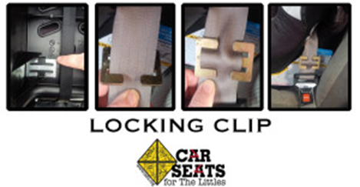

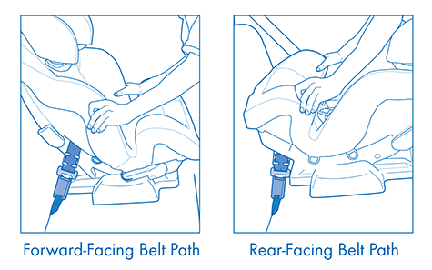

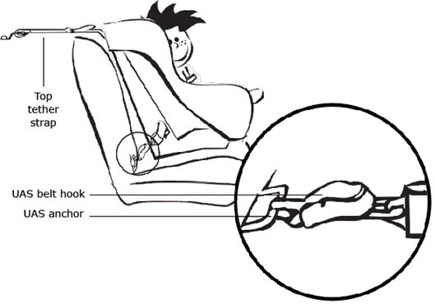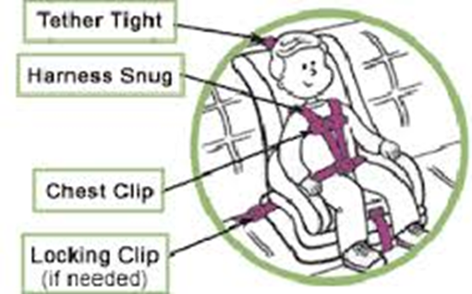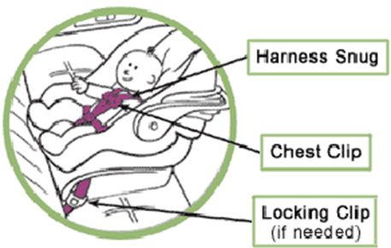

## Forward Facing

* Read the child safety seat instruction booklet for exact installation instructions
* Read the vehicle owner’s manual on how to install a child safety seat
* Safety seat must be Canadian-approved with a CMVSS label.
* Safety seat must be in the back seat of the vehicle

**Forward Facing: Until the child weights 40 lb (18 kg)**

**STEP ONE**

**SECURING the car seat – 2 systems.**

**1. Universal Anchorage System (UAS)**

* Check vehicle owner’s manual for UAS anchor location
* UAS belt is routed through the forward-facing belt path on the car seat
* Connect the UAS belt to the anchors
* Pull the UAS belt tight.

**2. Seat belt secured Car Seat**

* Check vehicle owner’s manual for how to lock the seat belt for use with a car seat
* Rout the seat belt through the forward-facing belt path on the car seat or base and buckle it up
* Put your knee in the car seat, push down and remove all the slack from the lap portion of the seat belt
* Test the belt to see that it has ‘locked’ in place and will not slip. If the seat belt slips, use a locking clip.

**STEP TWO – ALWAYS use the Tether Strap**

* Use the tether anchor installed in your vehicle, or have one installed by the vehicle dealer
* Hook the tether strap to the tether anchor in your vehicle according to the instructions, and ensure the tether strap is tight.
* The car seat should move less than 1 inch in any direction

**Buckling your child in the safety seat:**

* Shoulder harness is threaded through the correct slot, according to the car seat instructions
* Chest clip is position at the level of the child’s armpits
* Harness is snug so you can only fit one finger between the harness and the child’s collar bone.
* Shoulder harness system stays snug when you pull on it.

## Booster Seats

**From 40 – 80 lbs (18 - 36 kg) OR 9 yrs of age OR 4’9” tall (145 cm)**

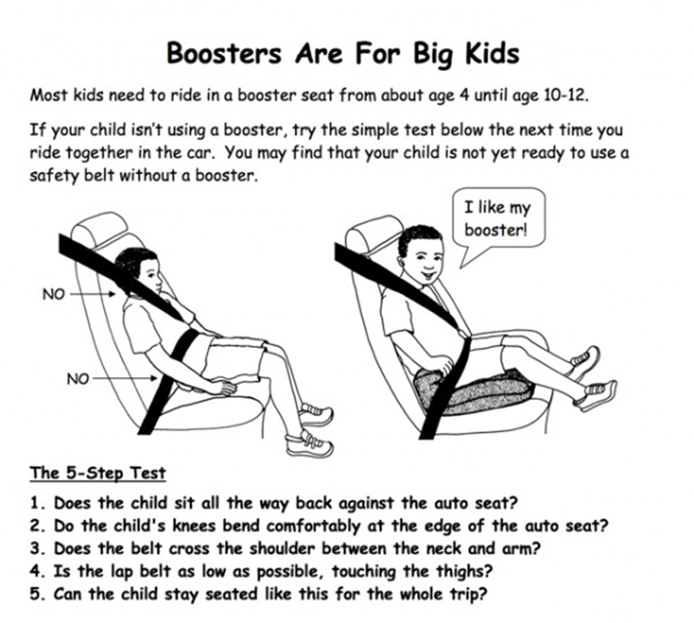

# BED BUG OVERVIEW

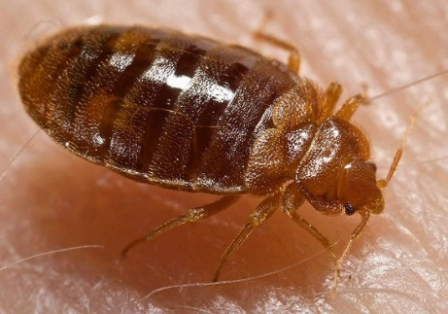

**FROM Capital Region Housing Corporation:**

* Know what to look for. Adult bed bugs are small, about the size on an apple seed, and tan or reddish-brown in colour. They can be found around beds and any furniture used for sleeping. They may be in the mattress seams, box springs, headboards, and behind baseboards. They leave dark spots from droppings and small bloodstains if they are crushed.
* If you are a renter and you find bed bugs, ***report them to your landlord immediately***. You cannot be evicted for reporting these bugs. If they come back later, let your Site Manager know again. **Do not try to treat the infestation yourself.**
* Vacuum your home, including baseboards, furniture, bed frames, mattresses and box springs regularly. Seal the vacuum bags with tape or in a plastic bag and remove them from your home right away.
* Wash your clothes and bedding in hot water. Dry them in a hot dryer for at least 45 minutes. The heat will kill the bugs. Do not overfill the washer or dryer.
* Keep your bed away from the walls and nightstands. Put bed bug proof covers on your mattresses and box springs. Use double sided tape or bed bug interceptors around the feet of your bed. Mattress covers and interceptors may be purchased from pest control companies or mattress stores.
* Follow all instructions the Site Manager or the pest control operator gives you to prepare before a chemical spray treatment or heat treatment of your home.
* Follow all instructions for after the treatment as well.
* Never bring used mattresses or furniture that you find in the alley or by a garbage bin into your home.
* Be very careful to inspect any used items you buy at a second hand shop or get from friends or family. If they appear to have bed bugs, don't take them.
* If you travel, check your luggage and belongings when you return home.
* When taking infested mattresses or other furniture out of your home, seal them in a large plastic bag. Tape a sign to the bag that says, "Infested with bed bugs". Do not donate or re-sell anything infested with bed bugs.

## Preparation For Home/Apartment Treatment Of Bed Bugs

**EXTREMELY IMPORTANT!**

• Remove all clutter from the unit.

• Remove all pets from premises. Unplug air to fish tanks. Cover fish tank with towel.

• Vacuum mattresses, floors, furniture, inside closets, dresser drawers, and nightstands.

• Pick up clothing or bedding from floor and hot dry for 45 to 60 minutes, then place in tight plastic container or sturdy sealed garbage bag.

• Do not discard any furniture until pest management professionals deems necessary.

**BEDROOMS**

• Remove all laundry, toys, and boxes from the floor. Seal laundry in plastic bags and put in bathtub.

• Put boxes on top of dressers. Put toys in plastic bags. Put bags on top of dressers or in bathtub.

• Empty all drawers from dressers and nightstands. Place contents in plastic bags with ties.

• Seal all bags shut and place them in the bathtub or on top of dressers.

• Move all furniture 12 inches from walls.

• Beds should have all bedding removed except “bed bug proof mattress/box spring covers.”

• Do not place anything on the beds.

**BATHROOMS / KITCHEN**

• Empty the cupboard under the sink. Empty all sinks. Throw out all garbage.

• Remove all food, dishes, pots and pans from counters, tables, and top of fridge.

**LIVING ROOM /DINING ROOM**

• Move all furniture 12 inches from the walls.

• Remove everything from couches and sofas.

• Remove all toys, laundry, boxes, and clutter from the floor

## Bed Bug Treatment Follow-Up And Clean-Up Guidelines

• Vacuum up all dead bugs. **DO NOT** vacuum or Clean within 6 inches of the baseboards.

• **ALL** bedding must be washed and dried in a hot dryer for 45 minutes. Do not hang items to dry. The heat of the dryer kills the bugs and eggs.

• **ALL** clothing must remain bagged up if more sprays are required. Use only the clothing you need and place it all back in bags after washing and drying.

• Put fresh bedding and covers on all beds and furniture before using.

Source: Edmonton’s Guide to Preventing & Getting Rid of Bed Bugs Safely

## http://www.healthycanadians.gc.ca/alt/images/product-safety-securite-produits/pest-control-products-produits-antiparasitaires/pesticides/tips-conseils/bedbugs-punaises-lits-1-360x203.jpgRecognizing a Bed Bug

**From its appearance:**

Bed bugs are small insects that feed mainly on human blood. A newly hatched bed bug is semi-transparent, light tan in colour and the size of a pin head. Adult bed bugs are flat, have rusty-red coloured oval bodies and are about the size of an apple seed. Bed bugs may be confused with other small household insects including carpet beetles, sowbugs and newly hatched cockroaches (nymphs)…

**From its markings, droppings and eggs**

Blood stains, droppings and eggs can be found in several locations including: • Mattress seams and tufts, sheets, pillow cases and upholstered furniture. • Crevices and cracks in furniture. • Baseboards of walls

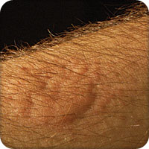**From its bite**

A bedbug bite can take as long as 14 days to appear, depending on the person. While bites can happen anywhere on the skin, they are often found on the face, neck, arms, legs, and chest.

Some people do not react to bed bug bites. But for those who do, bite marks may appear within days, usually where skin is exposed during sleep. They can be small bumps or large itchy welts. To avoid infection, try not to scratch the bites and keep the bite sites clean. Using antiseptic creams or lotions, as well as antihistamines, may help. Talk to your health care provider for advice. The welts usually go away after a few days. Because the bites may resemble mosquito and other insect bites, a bump or welt alone does not mean there are bed bugs.

## How They Feed and Live

Bedbugs come out at night to feed, attracted by the carbon dioxide we exhale. They will feed on both people and pets. Bedbug bites may not be noticed right away because bedbugs typically feed at night when people are asleep.

Bedbugs prefer locations where they can hide easily and feed regularly, like sleeping areas. Their flattened bodies allow bedbugs to hide in extremely small locations: under wallpaper, behind picture frames, in electrical outlets, inside box springs, in mattress pads, and in night tables.

Newly hatched bedbugs feed as soon as food is available. Bedbugs can live from several weeks to up to a year and a half without feeding. Older bedbugs can go even longer without feeding.

Adults usually live for around 10 months, but can live for a year or more in a home where the environment is good for reproduction (with temperatures ranging between 21°C and 28°C).

## The Health Effects of Bed Bugs

Although bed bugs and their bites are a nuisance, they are not known to spread disease. Bed bug bites can be very itchy and irritating. Most welts heal in a few days but in unusual cases, the welt may persist for several weeks. Usually an anti-itching ointment will help. Consult a pharmacist if itching persists or a doctor if bites become infected. The anxiety about being bitten can lead to sleeplessness, which can affect one’s wellbeing. Properly and effectively responding to bed bugs helps to keep anxiety in check. Some people become so desperate that they use illegal or excessive amounts of pesticides that can lead to poisonings. This guide provides advice on how to get rid of bed bugs safely.

## Bed Bug Prevention

* Get rid of clutter.
* Vacuum often, including under and behind beds.
* Repair or remove peeling wallpaper and tighten loose electrical faceplates.
* Seal all cracks and crevices on wooden bed frames, between baseboards, and in walls, ceilings, windows, door frames, and furniture.
* Check any entry points on walls that you share with neighbours, and openings that allow access to the inside of the wall (like areas where pipes, wires and other utility services enter).

## Be careful about what you bring into your house or buy

* Check every item you bring into your home for the first time, including used books, new furniture, and garage sale or antique store furniture.
* Be very cautious with second-hand or refurbished items.
* New mattresses are often delivered in the same truck that carries away old mattresses, so be careful to check your new mattress before it enters your home. Insist that your new mattress be sealed before it is delivered.
* Never take a mattress or sofa from a curb.
* Check items before you put them in your vehicle and check your vehicle after helping a friend move.

## Key Messages About Bed Bugs

* Dirty living conditions do not cause bed bugs but cleaning and removing clutter will help in controlling them.
* Anyone can get bed bugs; seek help immediately if you find them.
* Sealing cracks and small holes will help to reduce hiding places and prevent bed bugs from crawling between apartments.
* Cooperate with your neighbours, landlord and pest control operator; getting rid of bed bugs needs to involve everyone.
* Use only approved pesticides and be cautious how they are used, you can make your condition worse. It is hard, but not impossible to get rid of bed bugs. The advice in this guide will help.

## Checking for Bed Bugs

Regular inspection is important to prevent infestations. To thoroughly inspect your home, you will need a few simple tools:

* flashlight
* something to scrape along mattress seams and other crevices (like an old credit card cut into a long triangle: use it in a sweeping motion in narrow spaces to chase bedbugs out of hiding)
* screwdrivers for removing electrical faceplates and taking furniture apart (always be sure the power is turned off before opening an electrical outlet)
* alcohol, glass-cleaner, or baby wipes for checking if stains are bedbug droppings (if spots dissolve into a reddish brown colour when rubbed, the spots could be bedbug droppings)
* cotton swabs for checking stains in crevices
* white plastic bags that can be sealed, for your belongings

Check on, under and beside beds, couches and upholstered furniture. Look for black/brown spots (dried blood or feces), white spots (eggs - very hard to see), or live or dead bedbugs.

If you find signs of bedbugs, you should carefully widen the area of your inspection. If you have a pet, check areas where your pet sleeps as well.

**Check Walls and Wall Hangings**

• Using a thin putty knife or playing card, check paintings, posters, pictures and mirrors. • Check cracks in plaster and peeling wallpaper. • Inspect the face plates of electrical outlets and light switches (by eye only – do not insert anything into areas with wires). Look in phones, clocks, smoke detectors and toys

**Check Beds**

* Remove and inspect all bed linens, including pillows. If you see signs of bedbugs, wash the linens using the hot cycle of your machine.
* Slowly lift up each corner of the mattress and examine all creases, tufts, and buttons, along each side of any piping material sewn onto the edges, along mattress handles and air holes, and under pillow tops.
* Slowly lift up each corner and check where the box spring sits on the bed frame.
* 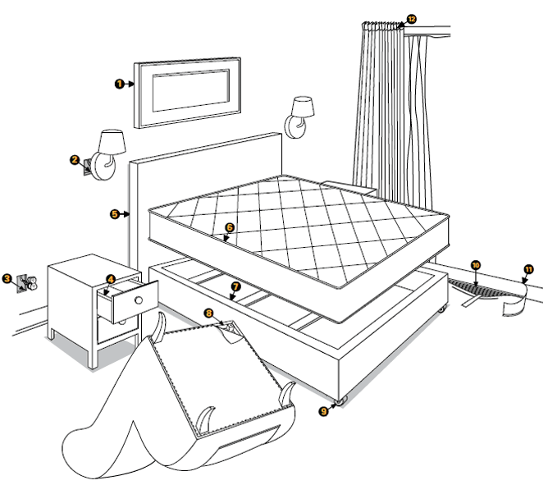Look closely at the top surface of the box spring, inside folds of material, along seams, and where the fabric is stapled to the box spring. Also check along the edge of the cloth underside. If you see signs of bedbugs, flip the box spring upside-down and remove the cloth underside to look inside the box spring.
* Check all surfaces, crevices, screws, staples, tacks, and under wooden plugs that cover screw or nail holes on the bed frame, legs, and headboard.
* Also go over the wall behind the bed (bedbugs can hide in wallpaper and electrical outlets). Remove electrical, telephone, or cable faceplates to check behind them. Always be sure the power is turned off before opening an electrical outlet. Pay extra attention to gaps in the baseboard or rips or bumps in wallpaper.

You should throw your bed out if you find bedbugs inside the box spring or where holes or worn spots in the fabric of the mattress are. These spots can allow bedbugs to lay eggs in places that are not easy to reach for treatment.

If you do throw out your bed or any other infested items, wrap them in plastic and tape off the edges to prevent spreading bedbugs on your way to the trash. Put a sign on the item saying it has a bedbug infestation, so that no one else takes the problem home with them.

**Check Furniture**

* Remove any loose cushions and check the creases, especially the seams and around the zippers of upholstered chairs and couches. Check the seating area and any creases along the sides and back of the chair or couch. Check the legs, especially where they join the upholstery, and where the fabric is tacked to the frame.
* Go over all corners and surfaces of wood furniture like dressers, cabinets, tables, chairs, and bookshelves. Remove drawers and look at the inside, the top, sides, back, and legs, paying extra attention to any cracks. Use the crevice tool to check any gaps (like between a shelf and bookcase frame, and under metal drawer slides).
* Wicker furniture is an ideal hiding spot for bedbugs, so check it carefully.

If you find signs of bedbugs, also check:

* 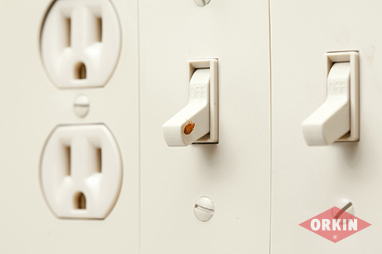Wall baseboards closest to the bed, using the crevice tool to check inside gaps.
* Between the folds of curtains, along the curtain hem, inside curtain rods and under the hardware on the wall.
* Around window and door casings and frames, along the hinges and in the hole for the door latch.
* Under area rugs and the edges of carpets. Fold back the edges of wall-to-wall carpeting and check the carpet tack strips.

If bedbugs are on the walls, they could also be hiding in picture frames, light fixtures, smoke detectors or other wall-mounted items. Bedbugs hiding in ceiling lights could mean that they are entering from a room above yours.

## Bedbugs - How do I get rid of them?

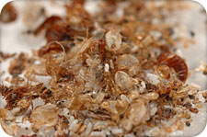Bedbugs are very hard to get rid of. If you do have bedbugs, it is strongly recommended that you hire a licensed professional pest control operator.

If you are a tenant and have bedbugs, you should tell your landlord right away. Tenants who have bedbug-related issues should speak with a public health officer for help in dealing with the infestation.

If you live in a multiple-unit dwelling and building management has asked you to prepare your unit for bedbug treatment, this usually includes emptying storage furniture to make it easier to inspect, organizing your belongings and placing them in bags, washing all your clothes and bedding, and moving furniture away from the walls. The pest control operator will usually give you specific instructions to prepare for an inspection or treatment.

Professional pest control operators can use a variety of tools to control bedbugs. These include liquid insecticide sprays, aerosol insecticide sprays, insecticidal dusts, diatomaceous earth, pressurized carbon dioxide snow, and steam and heat treatments.

Whichever treatment is used, **it will only be effective if physical control methods and preventative measures are used together**.

## Physical control methods

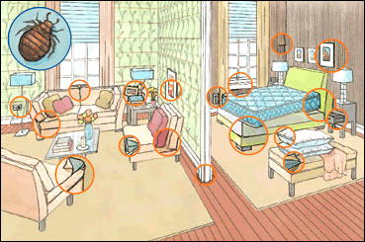Physical methods of controlling bedbugs include steam cleaning, vacuuming, heating, freezing, washing, and throwing out items. Steam cleaning should be done before vacuuming, as the steam will flush any bedbugs not killed out of hiding. Heat treatments should be left to the professionals.

**Trap and Kill Bed Bugs**

Force bed bugs out of cracks and crevices with a thin putty knife or playing card. Catch them with sticky packing tape or crush them in paper towels, seal in a bag and dispose in a garbage bin outside.

**Seal Cracks and Crevices**

• repair cracks in plaster, repair or remove any loose wall paper and tighten light switch covers.

• apply caulk to seal crevices and joints in baseboards

• apply caulk to seal gaps on shelving or cabinets

**Steaming, washing and throwing out items**

* Infested (but intact) mattresses, upholstery and plush items that cannot be washed with hot water and detergent should be steam cleaned. Bedbugs die at 50°C and steam cleaners generally emit steam at a temperature of at least 100°C. Dry steam or low vapour steamers are better because they leave behind less moisture. Steam will only kill the bedbugs that it reaches, so move the steam cleaner slowly to maximize depth. Avoid excess moisture, which could lead to mould.
* Putting small items in the freezer or outside is sometimes effective. However, freezing temperatures must be kept for a prolonged period (4 days of consistent cold at -19°C), and may not kill all of the bedbugs.
* Place small non-washable items and dry-clean-only items in a hot dryer for 30 minutes or more.
* Wash mattress pads, bedding, bed skirts, infested clothes, curtains, and so on in hot water and dry them on the hottest dryer setting. Store clean, dry items in light-coloured sealed heavy duty plastic bags or plastic storage bins with secure lids to avoid infesting other areas.
* Throw out any items that can't be washed, heated, or steam cleaned.
* Vacuum daily following the directions below.

**Vacuuming**

Handheld vacuums, vacuums with a cloth bag, and vacuums with hoses that are made of fabric are not a good idea for bedbug clean-up because these vacuums can become infested. For households with family members who have allergies or asthma, it's best to use a vacuum with a HEPA filter to avoid putting insect and dust allergens back into the air.

* Bedbugs cling to wood and fabric, and their eggs are cemented to the surface where they were laid. Using a stiff brush attachment and a back-and-forth scraping motion on the surface of the mattress, and a nozzle for the seams and crevices, carefully vacuum all sides to remove bedbugs and eggs. This includes the mattress, box spring, bed frame, baseboards, non-washable furniture cushions, any rugs and carpeting, around heating units and baseboards, and the inside and underneath all drawers and furniture.
* Let the vacuum run for a bit to make sure all bedbugs have been sucked into the bag, then dispose of the vacuum bag in a sealed white plastic bag (white plastic makes it easier to spot a bedbug), in a garbage bin with a lid.
* Stuff paper towel in the end of the vacuum hose and seal it with tape to prevent any bedbugs from escaping.
* Wash all vacuum attachments in hot water and detergent.
* Store the vacuum in a large plastic bag and seal it.
* For a bagless vacuum cleaner, follow the instructions above, but also empty the canister contents into a plastic garbage bag, seal and dispose of the bag right away, and wash the dust container in hot water with detergent.

**Using pesticides and pest control products**

Health Canada regulates pesticides in Canada. We make sure that each pesticide registered for use meets Canada's high standards for health and environmental safety, and that the product works as claimed on the label.

Each registered pesticide comes with a detailed label that provides directions on how to use the product safely, which pests it controls, where and on what it can be used, and how to apply it properly. To see if a pesticide has been registered for use in Canada, check the label for a Pest Control Products (PCP) registration number. If the product label does not have a PCP registration number, do not buy or use it. Unregistered pesticides are illegal in Canada and their safety and effectiveness have not been reviewed by Health Canada.

Follow these precautions when using pesticides:

* Carefully read the label before buying or using pesticides, to figure out which products are best for your situation and to use the product safely.
* Use only pesticides registered by Health Canada and only as directed on the label.
* Never use any treatment on people, pets or bedding unless the pesticide label specifically says to do so. For example, pesticides registered for use on bed frames are not meant to be used on mattresses or box springs.
* Do not use pesticides on baby cribs, playpens, or toys.
* Do not use homemade pesticides. While they may seem simple and harmless, many homemade pesticide recipes can be dangerous both to make and to use. They could harm you and your family.

## Bedbugs - How do I make sure they don't come back?

* Avoid moving to another bedroom. While you may feel a strong need to do so, surviving bedbugs could tag along which might lead to another infestation. Instead, continue to use the same bedroom, monitor carefully and often for any surviving bedbugs, and take the steps below to protect yourself from being bitten.
* Completely enclose your mattress and box spring in zippered bed encasements available from allergy or pest control supply companies. Put duct tape over the zipper, because zippers have a space where bedbugs can enter or escape. Mattresses can also be wrapped and sealed in plastic film. As long as the encasement stays intact (no rips or holes), the bedbugs will not be able to get through it to bite you and will eventually die. It is a good practice to keep the mattress enclosed this way for a full year.
* Coat bed legs with double-sided carpet tape or petroleum jelly, or place the legs of the bed in leg protectors or glass jars with a bit of baby powder to trap the bedbugs on their way up or down the bed leg. Commercially available bed leg interceptors are available and are a way to detect bedbugs.
* Use white or light-coloured sheets. This makes it easier to spot them.
* Remove headboards completely.
* Paint existing wood furniture (including baby cribs) white for easier detection. (Use only paint that is safe for use on baby furniture.)
* Replace upholstered furniture with metal or plastic, or material that can easily be cleaned with soap and water.
* Vacuum daily. For the first few weeks, even after you no longer see any bedbugs, throw out the vacuum bag right away, like you did during the treatment phase.
* Look for new infestations on a regular basis.

**Physical Control Measures**

This must be done as soon as possible and on an on-going basis until the bed bugs are gone (several weeks). It is important this is done before any chemical controls are used.

**A. De-clutter your home.**

• Throw away items you no longer need or use. This will reduce places bed bugs can hide.

• Put items you don’t use everyday into storage until the bed bugs are gone. Check all items again before bringing them back into your home.

• It is not usually necessary to get rid of furniture, mattresses or box springs at the first signs of bed bugs. Mattresses and box springs can be encased in bed bug proof covers.

• Your pest control operator will advise you if you need to discard any furniture. See page 18 for how to get rid of highly infected items.

**B. Washing & Drying**

• Wash all items showing bed bug stains in the washer (40-60C or 140F, hottest temperature) and put in the dryer on the hottest setting for at least 30 minutes.

• All clothing, linens, drapes and other fabric items must be placed in a hot dryer for 30 minutes to kill bed bugs and their eggs. If you cannot do this right away, place the items in a bag until you are able to.

• After drying, store items in tightly sealed plastic containers/bags until you are sure the bed bugs are gone from your home.

**C. Vacuuming:**

• Vacuum everywhere, especially where bed bugs mostly hide (see pages 6-7) daily.

• Use a crevice tool when vacuuming seams, folds, edges of furniture and mattresses.

• Empty the vacuum cleaner into a plastic bag, seal it and dispose of it outside.

**D. General Cleaning:**

• Wipe off dead bed bugs, blood stains, eggs and droppings with hot soapy water, especially around where you sleep. This allows you to see new bed bug activity.

• Place infested mattresses and box springs in a zippered cover designed for bed bugs for at least one year. Check for rips or openings regularly and tape these closed. Bed bugs do not chew holes in things.

**E. Make your bed an island:**

• Move your bed at least 30 centimetres away from the wall.

• Place interceptors (purchased or home made) under bed legs to prevent bed bugs crawling from the floor into your bed. Bed bugs don’t like climbing on smooth, shiny or sticky surfaces.

• Home made interceptors may be made using:

– double-sided sticky tape wrapped around the bed legs.

– petroleum jelly applied as a coating on the bed legs.

– smooth sided containers with vegetable oil or talcum powder in the bottom placed under the bed legs.

• Remove bed skirts and do not allow your bed covers to touch the floor.

• Do not put coats, clothing, purses etc. on the bed.

**Weekly Cleaning Measures**

Get rid of clutter to reduce places bed bugs can hide. After checking them for bed bugs, consider putting non-essential belongings into storage until the bed bugs are gone from your home. Check all items again before returning. Wipe off dead bugs, blood stains, eggs and droppings with hot soapy water. Wash all items showing bed bug stains in hot water (40-60ºC or 140°F) and dry on the highest setting for at least 30 minutes. Other clean items suspected of having bed bugs should be placed in a hot dryer for at least 30 minutes to kill bed bugs. After drying, store items in sealed plastic bags until you are sure you have gotten rid of the bed bugs.

Vacuum carpets, floors (3 – 6 centimetre strip along walls), bed frames, furniture, cracks and crevices daily, using the brush and crevice tools. Empty the vacuum and/or seal and dispose of its bag outside of your home after each use. Enclose infested mattresses and box springs in a cover that is labeled “for bed bugs” for at least a full year. Periodically check for rips or openings and tape these closed.

# HEAD LICE MANAGEMENT

**DID YOU KNOW:**

* Head lice are annoying and may cause itching, but they do not cause disease.
* Lice may be present on the scalp for weeks before they are discovered.
* Less than 50 percent of individuals scratch their scalp when they have head lice.

**PREVENTATIVE STRATEGIES**

* Check the heads of all family members on a weekly basis. Increase this to daily head checks when a case of head lice has occurred in the home, or one of the family members has been in contact with head lice.
* Treat only when live lice or live nits are found.
* Teach your child about prevention of head lice (avoiding head to head contact, not sharing hats, brushes, helmets, etc.).
* Tie long hair back.

**HEAD LICE FACTS**

* Head Lice are very common and can occur in people of all ages, races and classes.
* Head lice do not spread disease.
* Head lice are tiny insects about the size of a sesame seed and can vary from white to brown in color.
* Head lice **do not** jump or fly. They are spread by close head to head contact between humans.
* Head lice can move quickly on dry hair, so they are difficult to see.
* Head lice bites can make the scalp itchy.
* Adult female head lice lay about 3-10 eggs (called nits) every day. Live nits are glued to the hair very close to the scalp (within 6mm or ¼ inch).
* It takes 7-10 days for the nits to hatch into a nymph, and another 7-10 days for a nymph to become an adult. During that time, it stays on the head, but does not lay eggs.
* You can find nits anywhere on the head especially behind the ears or on the back of the neck.
* After the head lice hatch, the shell of the nit stays glued to the hair. If it is more than 6 mm or ¼ inch away from the scalp, it is probably empty or dead.
* Head lice are most commonly transmitted between family members, overnight guests and close playmates who spend a lot of time together.

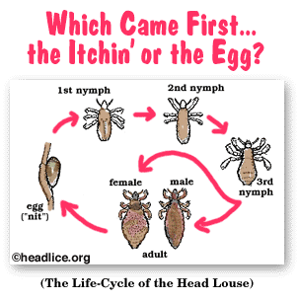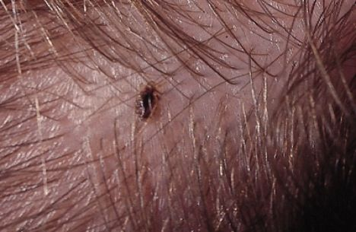

## How To Check For Head Lice

**What you need:**

|  |  |
| --- | --- |
| * Bright light * Regular comb * Lice or nit comb * White hair-conditioner | * Paper tissues, white is best * Plastic bag for garbage * A magnifying glass can be helpful |

**What to look for:**

You are looking for both live lice and lice eggs, also known as nits

* Adult lice are 2-4 mm long, about the size of a sesame seed. Lice move quickly and can be difficult to see.
* Lice eggs (nits) are shaped like tiny tear drops about the size of a poppy seed. They are glued firmly to the hair and will not move unless you pull them off with your fingernails or a nit comb.

**What to do when checking for head lice**:

* Apply a generous amount of conditioner to dry hair, soaking the scalp to the ends of the hair. Conditioner stuns the lice for about 20 minutes, and this makes it easier to find them.
* 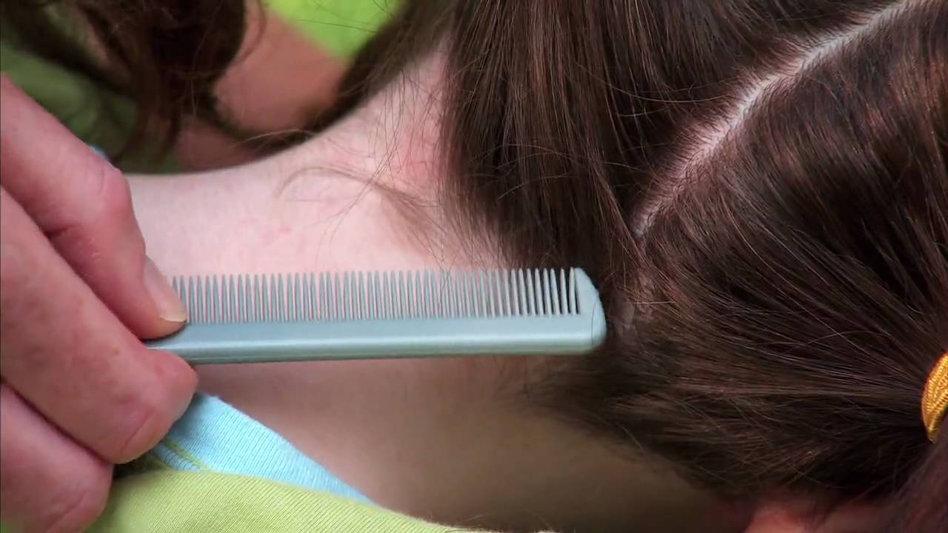Remove tangles with a regular comb.
* Start behind the ears and comb the hair section by section. Separating the hair with clips is helpful.
* Place the lice comb against the scalp and pull through to the end of the hair.
* With every stroke, check the comb for lice and wipe it off on a tissue. Looking at what is on the tissue helps to identify if you are finding lice or just regular hair debris.
* Place used tissues in a plastic bag (when finished tie off bag and toss).
* Repeat the process moving round the whole of the head, at least 5 times. Work section by section, so that the whole head of hair is combed through. It will take at least 15 minutes to do it properly.
* If head lice are detected and a drug store treatment is used make sure that **all conditioner is washed from the hair prior to treatment.**

**If you find head lice:**

* If you find live lice, you have a **confirmed** case that should be treated.
* If you only find nits and they are close to the scalp (less than ¼ inch or 6 mm) you have a **probable** case of lice. If your child has not been treated in the last month you should treat for head lice now (nits found further away from the scalp are probably dead and do not require treatment).
* Check everyone else in the household for lice, even if they do not feel itchy.
* Treat everyone in the household who has a confirmed case on the same day.
* You have choices in how you treat head lice; you can buy treatments at the drug store or choose to wet-comb the hair.

**TREATMENT OPTIONS A, B, & C**

CAUTION: Do not combine treatment options at the same time as this can reduce the effectiveness of each one.

|  |  |  |  |
| --- | --- | --- | --- |
|  | **A** | **B** | **C** |
| *What you do* | **Treatment Products:**  Shampoos or cream rinses | **Wet Combing:**  Uses a special nit comb and regular hair conditioner. | **Treatment Spray** |
| *How it works* | Works to kill the lice. Nits must be manually removed with daily combings (See B) | Removes the lice and live nits | Kills both lice and nits |

**ALTERNATIVE TREATMENTS:** No scientific evidence has been documented on the safety or effectiveness of alternative treatments. They are not recommended.

## OPTION A:Treatment Products: Head Lice Shampoo or Cream Rinse

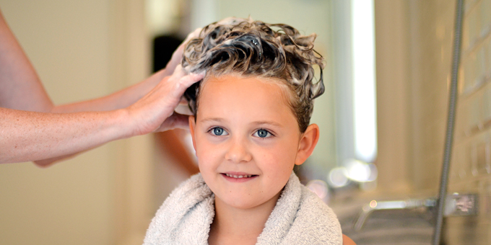**Kill the Head Lice and Remove the Nits**

* Head lice products should only be used when live lice and/or lice nits are found.
* This option involves using two treatments with a special head lice shampoo or cream rinse, 7 to 10 days apart.
* These products are available without a prescription from a drug store.
* The shampoo or cream rinse kills the lice on the head but may not kill all of the nits.
* The nits need to be removed using a special nit comb and by using your fingernails. Resistance and re-infestation can occur, consult a public health nurse.

**Ask your pharmacist about head lice products.**

**STEPS TO FOLLOW**

|  |  |
| --- | --- |
| **DO** | **REMEMBER** |
| 1. **Check the heads** of all family members. Check the entire head, especially behind ears and back of neck. You are looking for live lice and/or live nits (eggs). | 1. If one person in the family has head lice, there is a good chance that other family members have head lice too. Head lice move very quickly. Combing hair with a fine-toothed nit comb can help find live lice. *Wetting hair prior to combing may help.* Nits are glued to the hair; while dandruff can be flicked off the hair. Use good lighting when doing head checks. |
| 2. Treat all infested family members the same day.  **Read and follow the directions of the**  **head lice product carefully.**  Apply to dry hair | 2. Unless you treat all family members who have head lice at the same time, head lice can be passed on from one person to another when heads touch.  **Conditioners can reduce the effectiveness of treatments. Wash off conditioners and any hair products before starting treatment.** |
| 3. **Remove all dead lice and nits (within ¼ inch or 6 mm of scalp)** using a nit comb or your fingernails. Rinse nit comb or fingers in a bowl of warm water and wipe dry after each stroke, or wipe on tissues and throw these away in a sealed bag. | 3. Nit combs are available at your local pharmacy. It may help to untangle the hair first by combing with a regular comb.  *Experts differ in their opinion on the need to*  *remove nits. Nit removal is included here as it*  *helps ensure fewer eggs will hatch.* |
| 4. **Wash** clothing, sheets, towels and pillowcases used in the past 3 days, in water at least 55 C or 130 F and then dry in the hot cycle of the dryer for at least 20 minutes **or** put the items in a sealed plastic bag for 10 days or in the freezer for 48 hours.  Disinfect combs and hair accessories by  soaking in rubbing alcohol for 1 hour. | 4. There is **no** reason to do a major clean-up of the house to get rid of head lice. **It is more important to treat the head lice and remove the nits**.  Only items that have been in direct contact with the affected person need to be washed e.g. shirts, jackets, hats, towels, combs, brushes.  Vacuum floors, furniture, mattress, and car seat  where the infested child has spent time in the last 3 days. |
| 5. Treat a second time 7 – 10 days later. Repeat step 2 and 3 above. | 5. A second treatment will make sure that any head lice, which hatch after the first treatment, will be killed before they have a chance to lay eggs. Two treatments and a follow-up check of the head with nit removal for 2-3 weeks is the best way to make sure head lice are gone. |
| 6. If live head lice or new nits are found consult your Public Health Nurse or try another recommended option. | 6. If a few live lice are still found 8–12 hours after treatment, but are moving more slowly than before, this means the treatment is working and the medicine may take longer to kill all the lice.  If active live lice are found in the combings after treatment has been properly applied, the head lice may be resistant to the product chemicals.  If, after 24 hours following the treatment, no dead lice are found and lice seem as active as before, the medicine may not be working. Do not retreat right away with same product, wash off the first product and retreat as soon as possible using a product with a different active ingredient group than the one used. Or go to option B or C.  Speak with your public health nurse or pharmacist before you try another treatment and carefully follow the treatment instructions contained in the new product box. |

## OPTION B: Wet Combing: Using a nit comb and regular hair conditioner

**Remove the Head Lice**

* Wet combing is based on the life cycle of head lice. It is about removing the live head lice from the head.
* Combing treatments are done every 3-4 days over a three-week period. This breaks the life cycle of head lice by removing them before they are fully-grown and able to lay more eggs.
* This option is low cost and safe but takes time and requires that the steps below be followed **carefully and completely**.

**Talk to your Public Health Nurse if you require further information.**

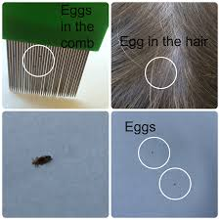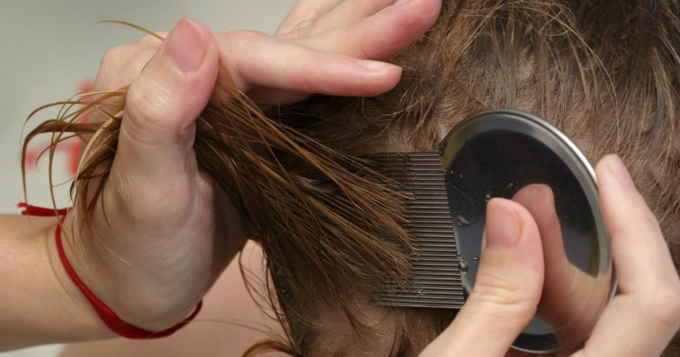

**STEPS TO FOLLOW**

|  |  |
| --- | --- |
| **DO** | **REMEMBER** |
| **1. Wash** hair with normal shampoo and  rinse. | 1. Note: On average, a wet combing session takes about ½ hour per person. |
| 2. **Apply** at least ½ cup (125 ml) of conditioner (any brand) to cover and wet all of the hair. Do not rinse out the conditioner. | 2. Untangle hair with a regular wide tooth comb.  Conditioner will slow the lice down. |
| 3. **Comb** sections of hair using a fine toothed lice comb. Divide hair into small sections. Firmly draw the comb from the scalp to the end of the hair. After each stroke, rinse the comb in a bowl of warm water, and wipe dry or wipe on tissues and throw tissues away in a sealed bag. Continue section by section until the entire head is done. Make sure hair stays wet with conditioner during combing. | 3. Metal or plastic nit combs are available at your local pharmacy. If the nit comb tugs the hair, use a wide toothed comb first and more conditioner, then try the nit comb again.  Make sure you have good lighting. |
| 4. **Rinse** hair. Leave hair dripping wet. Repeat Step 3 combing without conditioner, until no lice are found. | 4. Check the comb and your fingernails for head lice (you don’t want to give them a ride back to the head). |
| 5. **Wash** clothing, sheets, towels and pillowcases used in the past 3 days, in water at least 55 C or 130 F and then dry in the hot cycle of the dryer for at least 20 minutes **or** put the items in a sealed plastic bag for 10 days or in the freezer for 48 hours.  Disinfect combs and hair accessories by soaking in rubbing alcohol for 1 hour. | 5. There is **no** reason to do a major clean-up of the house to get rid of head lice. **It is more important to treat the head lice and remove the nits**.  Only items that have been in direct contact with the affected person need to be washed e.g. shirts, jackets, hats, towels, combs, brushes.  Vacuum floors, furniture, mattress, and car seat where the infested child has spent time in the last 3  days |
| 6. **Repeat** Step 1 – 4 at least every **3-4 days** for three weeks. | 6. Follow the schedule below. |

|  |  |  |  |  |  |  |  |  |  |  |  |  |  |  |  |  |  |  |  |  |  |  |
| --- | --- | --- | --- | --- | --- | --- | --- | --- | --- | --- | --- | --- | --- | --- | --- | --- | --- | --- | --- | --- | --- | --- |
| **DAYS TO WET COMB:**  **We Comb at least** every 3-4 days (or more often). Three weeks of wet combing has been shown to have the better results than just two weeks. | |  |  |  |  |  |  |  | | --- | --- | --- | --- | --- | --- | --- | | **1** | 2 | 3 | 4 | **5** | 6 | 7 | | 8 | **9** | 10 | 11 | 12 | **13** | 14 | | 15 | 16 | **17** | 18 | 19 | 20 | **21** | |

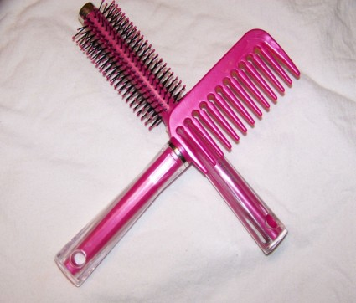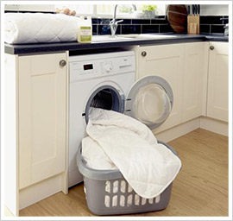

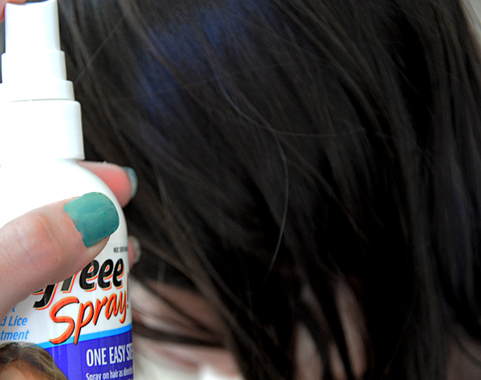

## OPTION C: Head Lice Treatment Spray

**Kill the Head Lice and Nits**

* This option involves using a special head lice spray purchased from a drug store.
* Two treatments must be used 8-10 days apart.
* The spray works by suffocating and killing the head lice and nits (eggs).

**Ask your pharmacists about head lice spray products.**

**STEPS TO FOLLOW**

|  |  |
| --- | --- |
| **DO** | **REMEMBER** |
| 1. **Check the heads** of all family members. Check the entire head, especially behind ears and back of neck. You are looking for live lice. | 1. If one person in the family has head lice, there is a good chance that other family members have head lice too.  Head lice move very quickly. Combing hair with a fine-toothed nit comb can help find live lice. *Wetting hair prior to combing may help.* Nits are glued to the hair; while dandruff can be flicked off the hair. Use good lighting when doing head checks |
| 2. Treat all infested family members the same day  Read and follow the directions on the  head lice spray carefully.  Apply to dry hair | 3. Unless you treat all family members who have head lice at the same time, head lice can be passed on from one person to another when heads touch.  **Conditioners can reduce the effectiveness of treatment. Wash off conditioners and any hair products before starting treatment.** |
| 4. **Wash** clothing, sheets, towels and pillowcases used in the past 3 days, in water at least 55 C or 130 F and then dry in the hot cycle of the dryer for at least 20 minutes **or** put the items in a sealed plastic bag for 10 days or in the freezer for 48 hours.  **Disinfect combs and hair accessories by soaking in rubbing alcohol for 1 hour** | 3 There is **no** reason to do a major clean-up of the house to get rid of head lice. **It is more important to treat the head lice and remove the nits**. Only items that have been in direct contact with the affected person need to be washed e.g. shirts, jackets, hats, towels, combs, brushes.  **Vacuum floors, furniture, mattress, and car seat where the infested child has spent time in the last 3 days.** |
| 4. Treat a second time **8 – 10 days after the first treatment. Repeat step 2** | 4. A second treatment will make sure that all eggs and live lice are killed. Two treatments and a follow-up check of the head is the best way to make sure head lice are all gone. |

## Alternatives Not Recommended

There is not enough scientific evidence to support the use of the following methods, therefore Interior Health does not recommend them as treatment options.

|  |  |  |
| --- | --- | --- |
| 🗶 Olive oil  🗶 Mineral oil  🗶 Vinegar  🗶 Mayonnaise | 🗶 Melted Butter  🗶 Vaseline  🗶 Robi comb  🗶 Follicel | 🗶 Cetaphil  🗶 Shaving Gel  🗶 Garlic |

## Undesirable And Dangerous Methods – Do Not Use

**The following treatments are not effective and/or not safe.**

|  |  |
| --- | --- |
| 🗶 Insect Sprays (Raid) Dyes  🗶 Oil (WD40)  🗶 Bleaches  🗶 Gasoline Chinese Chalk  🗶 Flea Soap Heat Directly on Scalp  🗶 Alcohol Kerosene | 🗶 Shaving the head is not recommended as a treatment strategy.  🗶 Essential Oils (Pine, Tea Tree, Thyme, Rosemary, Eucalyptus, Chick Chack etc.) are not recommended as there is limited scientific evidence and safety information on their use. |

## When Treatment Doesn’t Work

The most common causes of treatment failure include:

**Reason #1: Not having enough information about head lice or the treatment methods.**

The treatment methods can be confusing for many people, especially Option B which is based on understanding the life-cycle of head lice. If unsure about the treatment or prevention of head lice, please talk to your Public Health Nurse.

**Reason #2: The head lice treatment was not applied properly.**

The most common errors with using the treatments include:

* The hair had conditioner or a hair product in it before treatment was started. As conditioner and other products can coat the hair, they can make the treatments less effective if they are not washed off first.
* Applying the treatment to wet hair: Applying the product to wet hair dilutes the chemicals in the treatment. When exposed to water, head lice close their breathing holes which also make it harder for the chemicals to penetrate and kill the lice.
* Not using enough treatment to thoroughly cover all the hair: Thick and long hair will require more head lice product. Make sure you use enough head lice treatment to thoroughly wet all hair – especially behind the neck and ears. One way to make sure that you have covered all the hair is to comb the product through the hair with a regular comb.
* Not leaving the treatment on long enough: Chemicals in the treatment take time to work. Make sure you follow the product instructions.
* Not applying the second treatment 7-10 days later: With option A and C you need to use the treatment again 7-10 days after the first treatment. This is because no product kills 100% of eggs and eggs take 7-10 days to hatch. Therefore, re-treatment in 7-10 days is a mandatory part of treatment.

**Reason #3: The lice are resistant to the chemicals in the treatment.**

Head lice may be resistant to the chemicals in the lice treatment. If this happens, the chemicals are no longer able to kill all the lice. You can tell if the head lice are resistant by treating the head as directed, then checking for live lice. Use a fine tooth comb and look for movement. If the lice are moving less or are all dead the shampoo is working. If the lice are still very active they may be resistant to the chemicals in the treatment. Switch to another product with a different "active ingredient" or try one of the other options listed. Ask your pharmacist for help.

**Reason #4: The hair was previously washed using shampoo with built-in conditioner.** Conditioners in regular shampoos can coat the hair and make it more difficult for chemicals in the head lice shampoos to cover the hair and scalp.

**Reason #5: The nits weren’t removed.**

No treatment is 100% effective. Nit removal will help ensure effectiveness of head lice treatments and that there will be fewer eggs on the head to hatch. Daily lice combing is a must!

**Reason #6: The head lice treatment is too old.**

The active chemicals in many treatments weaken over time. Check the expiry date on the product before you use it.

**Reason #7:** Misdiagnosis (no active infestation or it a case of misidentification); **It is easy to mistake hair debris for nits. Nits cannot be flicked off or removed easily; they are cemented onto the hair.** Also, the symptoms (like itching) may be caused by something other than an active head lice infestation.

**Reason #8: Another infestation has occurred.**

If the above reasons don’t explain why the treatment hasn’t worked, re-infestation has likely occurred. Re-infestation almost always results from head to head contact with a person who has lice (re-infestation from the environment is very rare). If hair is clear one week after treatment, then head lice are found later, re-infestation has probably occurred. If you suspect re-infestation, ask your child with whom she/he has had head to head contact, and see if they can be checked. Look at direct head to head contact opportunities your child has had with favorite play mates and within the family.

