2016
Crossroads Family Services
A division of the family solutions group
FOSTER PARENT SURVIVAL GUIDE

TABLE OF CONTENTS
Part 1 - GETTING READY 4
1. Before the Child Comes – General Preparation 4
2. Three Years & Up – Setting up for Toddlers to Teens 5
BASIC CLOTHING 5
PERSONAL HYGIENE 6
BEDDING & BEDROOM 7
PLAY TIME 7
3. Newborn to 36 Months – Setting up for Babies 8
BASIC SUPPLIES 8
4. Getting Your Own Family Ready 10
PRIORITIES – Staying aware of your own family’s needs 10
YOUR KIDS AND FOSTER KIDS 11
Part 2 – ARRIVAL 12
5. First Day 12
MEETING YOUR NEW FOSTER CHILD – the 6 Ls 12
DOs and DON’Ts for Foster Parents 13
6. Settling In – What to Expect 13
Helping your Foster Child Settle In 14
7. School 15
TEN THINGS TO DO BEFORE SENDING A FOSTER CHILD TO SCHOOL 15
8. Answering Questions 17
TEACHING FOSTER AND BIO KIDS WHAT TO SAY 17
USING A COVER STORY 18
WHY PRACTICE ANSWERING QUESTIONS? 18
9. Grief & Loss 19
A CHILD’S EXPRESSION OF GRIEF & LOSS 19
THE STAGES OF GRIEF 19
ANNUAL GRIEF STRUGGLES 20
10. Pre-Placement Shopping & Check-List 22
Infants 22
Preschool 22
School-Age 23
House Preparations – All Ages 23
Part 3 – BEHAVIOUR MANAGEMENT 24
Positive Strategies 24
Strategies That Must Be Documented And Reported 24
Prohibited Strategies 24

Part 1 - GETTING READY

1. Before the Child Comes – General Preparation

Once you are approved to become a Foster Parent, it’s time to set up your home to accommodate your foster child. Below you will find a list to get you started. Some items only apply to certain age groups, so adjust your preparations accordingly.
A few things to keep in mind:
- These expenses are not reimbursable.
- This is only a start – it is not a complete list.
- These basic preparations must be done in your home before your first placement

Bedroom for Kids to Teens | - WINDOWS must have adequate window coverings  - LIGHTING (overhead, bedside, nightlight) as age-appropriate  - MIRROR  - DECORATIONS (age appropriate) – allow child to choose some  - BED with sheets, blanket, pillow, mattress cover  DRESSER, storage space or shelves for possessions  - ALARM CLOCK (for older children)  - CLOSET SPACE with hangers
Bedroom for Babies & Toddlers | - CRIB - CSA-approved crib and bedding  - SUPPLIES - small toys, diaper bag, lotion, shampoo, baby powder  - CLOTHING – diapers, sleepers for your age range  - FOOD - formula, baby food, bottles  - FURNITURE – Changing table, high chair or booster seat for eating
Personal Hygiene | - tooth brush & tooth paste  - hair brush & comb  - towel & cloth  - soap, shampoo, conditioner  - deodorant (9 and up)
Family Spaces | - a seat at the kitchen table for your new child & booster seat if needed  - a place to hang up and store jackets, coats, hats, mittens, shoes and boots  - enough seating in the living and family room to include the child
Transport | - car space enough for everyone  - new CSA-approved Infant or booster seat, properly installed with tether strap or seat belt
General Home Safety | - TODDLERS: electrical outlet covers, drawer and cupboard  - fire extinguishers, smoke and CO2 alarms  - fireplace screen or cover, protected wood burning stove  - hand rails on all steps
Medical | - over the counter medicines (cough syrup, Baby Aspirin, Tylenol, etc)  - oral thermometer  - first aid kit  - ‘Lice Kit’ – lice shampoo, special comb (just in case)  - emergency phone numbers (Crossroads provides)
Memories System | A way of collecting photos and memorabilia for the child to take when s/he leaves:  - photo box or album  - life-book or scrapbook

2. Three Years & Up – Setting up for Toddlers to Teens

BASIC CLOTHING
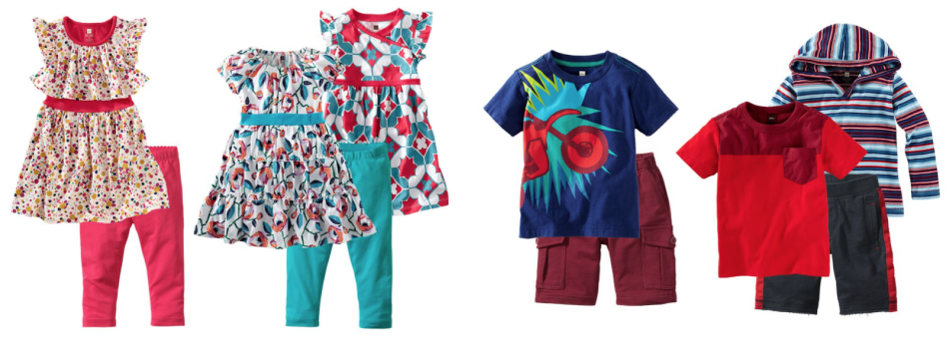
Your foster child may arrive with little or no clothing. If this is the case, the child’s caseworker may provide you with a clothing voucher to get you started on providing your foster child with an adequate wardrobe. (Instructions on using the clothing voucher can be found in the child’s Placement Package.) Once the child has the basics, you will use the child’s clothing allowance (included in your daily stipend) to purchase clothing.
Prior to having a child placed, it’s a good idea to go to a Second Hand store and pick up some basic items to accommodate a child who arrives with only the clothes they’re wearing. Purchase items that might fit a range of sizes within the age group you plan to foster.

Prior to Placement
Have on hand at least one of each item below BEFORE you take your first placement:
- Sweatpants  - T-shirt or sweatshirt  - Socks | - Underpants  - Pajamas or nightie  - Sweater or Jacket | - Slippers or flip-flops  - Seasonal: Mitts, toques, boots, poncho

A Full Wardrobe
Each month you will use the clothing allowance to build up to a full wardrobe for the child. A sample wardrobe may include:
- 7 Tops (t-shirts, shirts, blouses)  - 5 Pants  - 5 shorts (summer)  - 1 Dress outfit (for court/church)  - 2 Footwear (shoes, runners) | - 3 Pyjamas  - 7 Socks  - 7 Underwear  - 1 Light weight Jacket  - 1 Winter Coat | - 1 Winter boots  - 1 Rainwear (Boots, raincoat/poncho)  - 1 Mitts, touque, scarf  - 1 Packsack (school, visits)

NOTE: For potty training toddlers get extra shirts, pants, shorts, underwear, and night clothing.

Clothing for Visits
Most children go on visits to their bio-family. Toddlers and children going for overnights will need to take a change of clothes. Foster parents are encouraged to send clean, mended older clothes on visits. For the most part, the visit will involve playing, and in some cases the change of clothes may not come back from the visit. Save new clothing for school. When the child is discharged from your home, all the clothing purchased will go with the child to their bio-family or new placement.

PERSONAL HYGIENE

Have on hand the following items BEFORE you take your first placement: You’ll want two of the personal items in case you get siblings.
TWO EACH OF:  - Toothbrush  - Comb  - Brush  - Deodorant | ONE EACH OF:  - Shampoo (no-tears for toddlers)  - Skin lotion  - Baby wipes  - Pads and tampons

- Toothbrush/Toothpaste; Comb/Brush Keep a few toothbrushes, combs and brushes on hand for new children. Always use personal hair brushes in case of lice.
- Deodorant - Consider the age of the child with this product. Junior High is about the time deodorant is needed. Some children may require it earlier.
- Shampoo - Consider tear-free for toddlers.
- Hair Care Products for children of different ethnicity (e.g.: special shampoo for Afro hair). When possible, ask what the child has been using. You may also call a local salon or check the internet. (Remember – do NOT cut the hair of an Aboriginal child without specific permission from the Caseworker.)
- Lotion - Especially for ethnic skin care needs (e.g.: children with Black skin often have dry skin issues).
- Baby Wipes for quick clean-up of hands and face after meals. Also needed for potty training accidents.
- Menstrual products (Be prepared for girls as young as 10 years old. Be sure to ask if they need this. They will probably be too shy to tell you.)
- Pull-Ups and/or GoodNites: Older children may have, or revert to wetting or soiling after coming into care. Do not offer Pull-Ups or GoodNites unless the child demonstrates they have a problem. Talk with your support worker before approaching this delicate subject with the child.

NOTE: Tweens and teens may require additional skin care products. Take them shopping so they can pick out their own. Teen girls can purchase their own make-up with their allowances.

BEDDING & BEDROOM
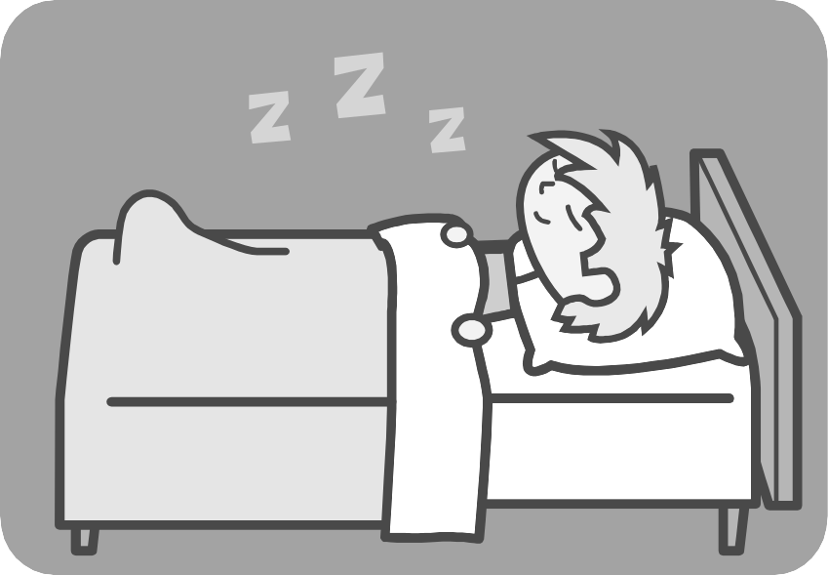
Children may share rooms, but each needs their own private space. Sleeping areas should feel safe and cozy. Adequate supplies will allow you to keep the child’s bed clean and fresh in case of accidents. Some youth will regress in behaviour during times of stress and may start wetting the bed. Toddlers may be in the midst of toilet training.
- Night Light - Have on hand just in case.
- 2 Sets of sheets (double for toddlers and/or bedwetters)
- 2 Light Weight Blankets (double for toddlers and/or bedwetters)
- Heavier Blanket or Comforter
- Plastic Sheet Mattress Protector (optional)

PLAY TIME
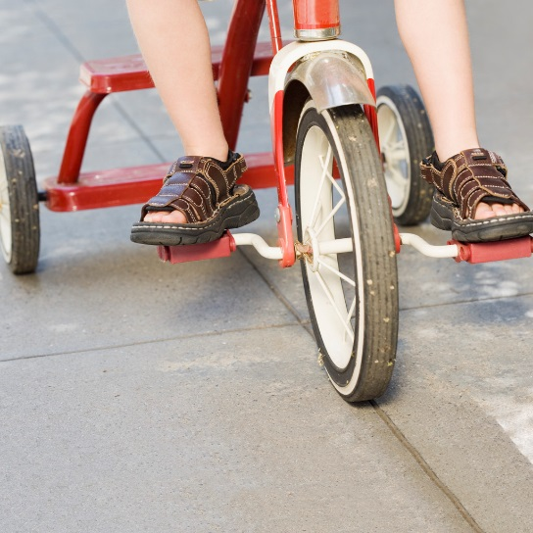
AGE APPROPRIATE TOYS
A child will feel welcome in your home if there are already age-appropriate toys available for all the children to play with. These should not be personal toys belonging to your bio-children, but ‘family toys’ for everyone to share. (Garage sales are a great source)
- Stuffed Animals (freshly washed)  - Lego  - Barbies / Dolls - Girls  - Action Figures - Boys  - Cars and Trucks  - Books of various reading levels  - Outdoor toys | - Board Games and Puzzles  - Crayons and Color Books  - Building Blocks  - Videos / DVD’s  - CD’s of children’s music  - Electronic games for older children  - Equipment for sports your family takes part in

Foster parents are expected to provide toys, activities and supervision for children in their care. Have a few basic toys on hand until you get to know the child. When purchasing, check the packages for age appropriateness and use as a guideline when setting up your toy room. Also keep in mind whether certain toys would be a choking hazard for toddlers.

MY OWN STUFF!

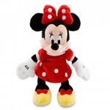
Children need their own possessions. Once settled, take your foster child shopping with you so they can choose things for themselves. While it’s important to have clothing and activities available for a new foster care placement, children need the opportunity to show you who they are by picking out their own toys and clothes, within reason. Be sure other children in the home respect that these new items belong to the foster child, and not to everyone.

3. Newborn to 36 Months – Setting up for Babies

BASIC SUPPLIES

Your foster baby may arrive with little or no clothing. If this is the case, the baby’s caseworker will provide you with a clothing voucher to get you started on building up an adequate wardrobe. (Instructions on using the clothing voucher can be found in the child’s Placement Package.) Once this is done, you will use the baby’s clothing allowance (included in your daily stipend) to purchase clothing.
Prior to having a baby placed, visit a Second Hand store and pick up some basic items to accommodate a child who arrives with only the clothes they’re wearing. Purchase items that will fit a range of sizes within the age group you plan to foster.

Prior to Placement
To begin, have on hand the following items so you don’t have to go shopping the moment the baby arrives. These will be your own to keep and use again for new placements.

CLOTHING & HYGIENE  - 4 nightgowns or sleepers in varying sizes  - disposable or cloth diapers in varying sizes  - disposable wipes  - latex gloves  - new soother  - 2 burp pads | BEDDING & EQUIPMENT  - crib (no bumper pads)  - 2 sets of sheets, 2 crib blankets  - change table and waterproof pad  - play pen  - high chair  - baby bottles  - formula

NOTE: You will be required to provide formula, baby food and diapers for the baby. Additional monthly funding is available for placements 0 – 36 months old, but when the baby arrives, you need to be ready.

Questions to Ask the Caseworker:
1. Will the baby be coming with formula and baby food?
If yes, will there be enough to last for a few days?
If no, what kind of formula and baby food is the baby used to?

2. Will the baby arrive with diapers?
If yes, how many?
If no, what size will the baby need?
Universal Precautions!
Foster parents are required to use latex gloves EVERY TIME they change a baby’s diaper until such time as the baby has been seen by a doctor and there is no risk of infectious disease.

BABIES MIGHT ARRIVE
IN THE MIDDLE OF THE NIGHT.

Have a few days’ supply of baby food and diapers on hand. This will make welcoming your foster baby a pleasant time, rather than stressful.

A Full Wardrobe
Each month you will use the clothing allowance to build up to a full wardrobe and supplies for the baby. Anything purchased with a clothing voucher or with the baby’s clothing allowance will belong to the baby and go with her when she leaves your home.
The following is a sample wardrobe you can work towards:
Clothing and Layette
- 5-10 onesies/undershirts or rompers
- 5-7 baby sleepers or nightgowns
- 1 cold weather sleeper if necessary
- 5-7 pairs of baby socks
- 1-2 hats, depending on climate
Diapers and Bath Items
- 2 packs of disposable diapers or enough cloth diapers for at least two days. Newborns can soil up to 10 diapers per day.
- Pullups for toddlers who are toilet training
- 1 pack of disposable wipes or 10 cloth wipes

- Box of latex gloves
- Waterproof pad for diaper changes
- 3-5 baby washcloths
- 1-2 hooded or regular towels
- 1 bottle of gentle baby wash
- Baby hair brush (helps loosen cradle cap)
- Baby nail clippers
- Digital thermometer
Baby & Toddler Needs: Bedding and Feeding
- 3-4 fitted sheets for crib
- 5-7 lightweight blankets
- 1-2 heavier blankets, depending on climate
- 10 burp cloths or 4 – 5 bibs
- 5-8 bottles, or 2-3 sippy cups
- ‘Breastfeeding’ pillow, if desired

Clothing for Visits
Most children go on visits to their bio-family. Babies and toddlers often need a change of clothes for daytime visits as well as overnights. Foster parents are encouraged to send clean, mended older clothes on visits. For the most part, the visit will involve playing, and in some cases the change of clothes may not come back from the visit. Save the new clothing for school. When the child is discharged from your home, all the clothing purchased will go with the child to their bio-family or new placement.

4. Getting Your Own Family Ready

PRIORITIES – Staying aware of your own family’s needs
Your own family is your first priority. Remember that you are fostering as a family, and everyone is part of the fostering team. Talk with your children individually or at a family meeting.

It’s important to consider the needs of your own family and help them prepare for this change in the home.

Discuss the type of child you may be fostering: a baby, toddler, teen, girl, boy, etc.

Discuss ‘What if’ scenarios so everyone can explore ahead of time how they might feel.
- What if Mom has to spend extra time with the new child to take him to appointments?
- What if Dad can’t get to your soccer game because he is taking the child to a bio-family visit?
- What if you have to take the bus to school because Mom is registering the new girl at a different school?
- The new child might be getting new clothes, and maybe toys as well. Explain that these aren’t presents, but necessities.

Plan some special times with your biological children. You might want to plan for individual ‘dates’ for a meal or a favourite activity. Be organized and purposeful in your attention to your own children. Bringing in a foster child may be as stressful for them as it is the new child.
Expect and allow your children to be resentful of a new person joining the family. Encourage them to express this to you so that you can help them address and work through any problems/issues.
Discourage “secret-keeping” within your family. Encourage your children to come to you if they hear or see anything that upsets them, or that they know is against the household rules.
Protect your family by giving information that will keep your family safe. For instance: Do not share anything that could pass disease like a brush or a comb or earrings.
Teach your children about good touch and bad touch. Make sure they know what is behaviour is appropriate and inappropriate. Some foster children may act out sexually or physically. Telling you if this happens is not tattling.
Your children need to know how to say, "no" and how to get away from any uncomfortable situation. In the case of young children, you will need to maintain supervision at all times until you are comfortable with the new child.
KEY CONCEPT!
The foster child does NOT change to fit our family.
Our family changes to fit the child.

YOUR KIDS AND FOSTER KIDS

Preparing Your Children for Their Foster Sibling
- Make sure your kids know that the new foster child may be upset when they first arrive, so give them space and lots of understanding.

- Teach your children not to ask the foster child a lot of questions about their birth home, life and experiences. Wait until they’re ready to share of their own accord.

- Teach your children the importance of confidentiality. They should not tell anyone
about the foster child's birth family and situation.

- Teach your children the importance of role modeling good behavior. Let your children know how their example will be a great teaching tool.

- Let your children know that the new foster child will have the same rules and chores so that there are no hard feelings. Make them aware that it may take a few days for them to get comfortable with doing their chores, and that you will work with them until they’re as good at them as your bio children. Establish chores with the new child and go over the household rules within the first week of being placed in your home. This gives the child time to adjust, but lets them know they are a part of a working family.

- Put up a “‘Family Chores” chart so that everyone knows what is expected of them.



Part 2 – ARRIVAL

5. First Day

MEETING YOUR NEW FOSTER CHILD – the 6 Ls
1. LASAGNA - Let the child know that you will be meeting basic needs.
Have food available. The child may not have eaten all day, and may be too afraid to tell you. Ask them about any other basic needs that they may be too shy, frightened or embarrassed about: hungry, thirsty, medical needs, a girl 10 years or older may be menstruating, etc. Older children will appreciate knowing where they can find their own snack if they’re hungry.
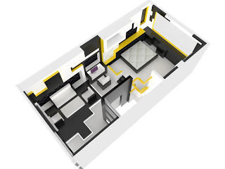
2. LAYOUT - Tour of the home, ending with his/her room.
Identify any areas that may require permission before entering, such as bedrooms or an office. Talk a bit about the different family members as you show the child around, to begin the process of connecting with the child.

4. LABELS - Introduce the members of your household.
If family members are not home when the child arrives, or if they are asleep, just quickly review who lives in your house. Prepare the child ahead of time so that there are as few surprises as possible. And don't expect the child to remember any names.

Agree on a name that the child can call you (e.g.: first name, 'Auntie, Uncle ...., etc.) Young children will often spontaneously start calling you Mom and Dad.

5. LICE & BATH - Do a discreet lice check and provide the child with a bath.
Be sensitive to the child's emotional state. Children under 5 years old will probably need your help to bathe. Children 5 years and older should be asked if they need help in the tub – maybe they will only need you to wash their hair. Children may be resistant to bathing, for various reasons:
- They may be unaccustomed to regular bathing and simply can't see the need
- They may feel that 'getting naked' makes them too vulnerable
- They may have a history of molestation, and taking off clothes makes them panic
Negotiate. Maybe they will feel safe if they bathe with their underwear on, or if you sit outside the bathroom door and talk to them so they know that someone is 'guarding' them. Look for a solution that allows the child to feel that their needs have been heard and addressed.
6. LAWS - Review your family's basic rules and expectations.
It's helpful to post a simple sign stating your “Family Rules”. Your foster child will probably be in shock when s/he arrives at your home, and will not remember much of what s/he is told at the beginning.

DOs and DON’Ts for Foster Parents
New foster parents want the very best for the child who comes into their home. In their excitement, some make some common mistakes that can overwhelm the child.

✓ DO be honest when answering your foster child’s questions.


Make yourself available to listen if they want to talk. Children will open up more easily if you avoid questions they might answer with “yes” or “no”. Instead, ask such things as “What’s your favourite…” or “What food don’t you like?” Talk about activities, meals, stories, games or shows. If the child asks about their situation, visits with family etc., always be clear, age appropriate, and above all honest with your answers. Do not promise a visit tomorrow if you don't know that to be fact. Don't invent answers. It’s okay to say, “I don’t know, but I’ll find out as soon as I can.”

✓ DO call your Foster Care Support Worker if you have questions. Your FCSW is expecting questions and ready to discuss them with you. That’s what we’re here for. You’re not in this alone.

✓ DO be calm, respectful and matter-of fact as you orient the child to your home and family.
780-430-7715

✓ DO be friendly, smile at the child, and show him he is welcome by demonstrating that you’re prepared for him (food, a room and bed, clothes if he needs them, toys, etc.)

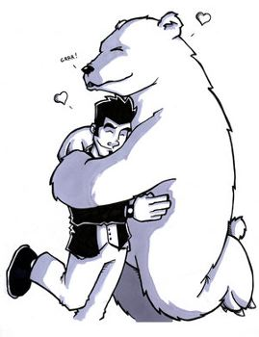
X Don’t invite your friends and relatives over to meet the child as soon as he moves in. This may be extremely overwhelming to the child. Allow these meetings to occur naturally and gradually.

X Don't throw your arms around the child and smother him with kisses as soon as he walks in the door. You’ve been expecting a child into your home, but the child most likely has not been expecting to come into foster care. Such physical contact is an invasion of the child's space by a stranger. This can be very scary for a new foster child.

X Don't tell the child how happy you are to have him in your home. This suggests that you are happy that he was apprehended from his own home and placed with strangers.

6. Settling In – What to Expect

After your foster child is placed in your home you can expect that it will take him a while to settle in and to get used to your family and your routines. The foster family must be prepared for this adjustment period and the behaviours that commonly come during this time.

Common behaviors during the child's adjustment period include:
Don’t hesitate to call us!
Difficult behaviours during this adjustment period are normal. Your Support Worker needs to know how the child is settling in, so be sure to call during this initial period.
- Testing of the rules and limits you have set
- Withdrawing--extreme quietness and timidity
- Eating a lot or not enough
- Extremely rigid in likes and dislikes
- Trouble sleeping
- Tears and/or tantrums
- Problems in school
- Running away (AWOL)
- Disobedience
- Aggressiveness
- Bedwetting
Sometimes this behavior develops immediately after placement. In other cases, a 'honeymoon' period exists and the behavior problems don’t begin until a few weeks into the placement. In either case, it can be a most trying time for both the foster child and the family. This is a time when you will want to work very closely with your Support Worker.
780-430-7715

Helping your Foster Child Settle In
Your job as foster parent starts before the child arrives, with your preparations of emergency clothing, a safe place to sleep and a place to store his/her things. When the child first arrives, and during the days, weeks, and sometimes years he is with you, your job will change and grow as you get to know the child and as he fits into your family.

The list below summarizes some of the ideas already talked about and highlights concepts you learned in Orientation Training; ones we feel are critical to settling your foster child into your home and family.

- Welcome your foster child quietly.

- Orient him to the most important things right away: his bedroom and his space to store things, his chair at the table, the bathroom, bedtimes and mealtimes, what he can take for a snack, what to do if he wakes in the night, and who lives in the house. Be sure to repeat these things until he’s showing he is well oriented.

- Let him know what to call you. Since he may not be ready for another Mom or Dad, provide a choice, letting him know what is agreeable to you, too.

- Let the child know the rules of your home and be consistent in enforcing them.

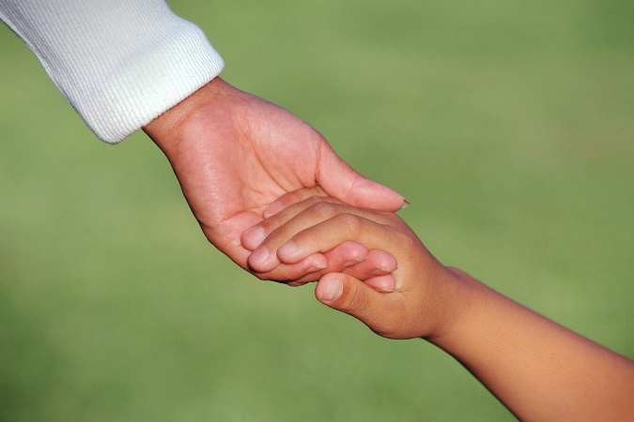
- Help him settle into a regular routine and regular household chores as quickly as possible.

- Do not be disappointed if the child does not respond to you immediately.

- Give the child the opportunity to talk to you.

- Respect his perspective and feelings for the things in his past.

- Take his lead but do not probe into his past life or criticize his parents.

- Encourage the child to trust and talk to his caseworker. Do not threaten a foster child with his caseworker as a means of dealing with his behavior.

- Help the child develop a feeling of pride and confidence by giving him tasks within his ability.

- Look for positives. When the child succeeds at something, no matter how small, express sincere pleasure and recognition of his abilities.

- What a child says, or how a child outwardly acts is often not how he feels, in fact, it can often be just the opposite of the real feeling.
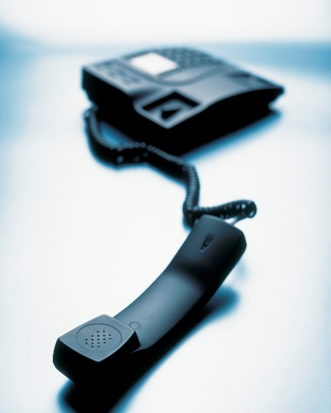
- Refrain from ridiculous, severe or humiliating punishments. At all times corporal punishment is forbidden.

- Do not threaten a child with giving him up. He will be helped most by your love and understanding and a feeling of security.

- Call your support worker with questions, or just to discuss how your foster child is doing.

7. School

TEN THINGS TO DO BEFORE SENDING A FOSTER CHILD TO SCHOOL
1. Health
Within 10 business days of admission to your home, you will have taken the child for a medical check-up or will have made an appointment for a checkup.

Find out if the child's immunization records are up to date. If s/he is from a home in the area, your local Health Unit should have their records on file. If not, check with the child’s caseworker.


2. Paperwork
Sometimes children continue attending their old school. If you are registering the child in a new school, call them ahead of time to ask what paperwork will be required. Go prepared with your delegation/subdelegation and as much of the required information as possible.

3. Know the Child's Education Plan
Does the child have an Individual Education Plan(IEP) for special education, behavior, and/or speech classes? The child’s caseworker should have this information.

4. Ensure that the child knows your name, and who to call in the event of an emergency.
Children new to your home need to know this for safety and for school. Make sure they know your full name, how to spell it correctly, and where you work.
5. Practice the Route to School or to the Bus Stop
Show the child the route they are to take and make sure it is a safe route. Walk or bike it with them. Practice skills such as:
- Crossing the street
- Yielding to traffic
- Stopping at stop signs
- Locking up bikes
- Knowing the correct bus number

Do not assume that your child knows these things. Practice, even if the child says they know. Most children who say that they know how to ride a bike safely, in reality do not know. Always ask them to demonstrate their skills. Try making it a game instead of a test. Go on a family bike ride. See how they handle traffic. Don’t forget helmets!
If you will be picking up the child after school, be sure that both of you know where you will meet at the end of the day.
6. Attend Open House or Tour School Building
You and your child will be able to meet the teachers and will be able to tour the school. If school is already in session, ask for a tour and to visit the child’s room when you enrol, then have them begin the next day. End the trip with a lunch date out. It gives your child a chance to get used to everything before actually starting school.
7. Discuss Safe Rides
Make sure the child knows who they can get into a car with and who they cannot.
Remember to talk about neighbors, social workers, and close relatives.
Teach them to look for ID/name tags on people claiming to be social workers.
Discuss who not to catch a ride from. Include strangers and anyone you’d rather not have your child be alone with.
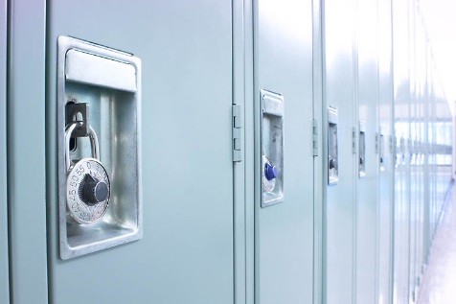
8. Practice Opening Lockers
This is such an embarrassing thing for kids – being late to class or to gym because they can't open their lockers. Use the time you have at enrolment or at an open house to practice. Get a lock at home and practice.

9. Be Involved with the Child’s Education and with the School
This is great for foster parents too. Volunteer to be a room parent and help plan holiday parties for the child’s class. If you don’t have time to attend school parties, bake cookies or send a bag of candy. Go on field trips or volunteer to come in and read to the kids. Most kids love to see their parents or care givers being involved in their activities.
10. Practice Answering Questions
Talk to your foster children about their right to privacy. Rehearse what the kids may want to tell others about why they are now in your home. As well, it is helpful for children to have permission to refer to you as 'Mom/Dad' when talking to others, even if they don't call you that.

8. Answering Questions

TEACHING FOSTER AND BIO KIDS WHAT TO SAY
Being a foster child brings with it some unique problems. Part of your job is to help your foster child figure out his/her best way to deal with these problems that usually surface in the form of questions from peers and adults.

Teach children that they do NOT have to answer every question. Your child's business is his/her business alone!

Q: Someone may ask, "Why didn't your mom want you?" or "Do you know your REAL mom?"
A: Your foster child may answer, "I don't want to talk about this right now", "I don't share personal information", "I am wanted by my family", “I am wanted and loved by more than one family”, "I know who my parents are, and they love me very much" or simply walk away.

Q: Someone may ask, "Why are you in foster care?"
A: Your foster child may answer, “That’s a private matter” or again, just walk away.

Teach your child to use humor. Sometimes a quick wit can end an uncomfortable discussion.

Q: Someone may ask, "Why don't you look like your mom?" or "Why don't you look like your sister/brother?"
A: Your child may answer with, "Because I'm better looking!"

Q: Someone may ask, "What does it feel like to be in foster care?"
A: Your child may answer with, "What does it feel like not to be in foster care?"
Answer honestly and simply. No need to add any unasked for information.

Q: Someone may ask, "Do you miss or think about your birth parents?"
A: Your child may answer with, "Yes, I do.” If questions persist, he may want to add, “Please don't ask me about this, I don't want to talk about it right now."

USING A COVER STORY
Cover Stories are just that - stories to provide cover or protection. Using cover stories is not about telling lies, it's about keeping information private that could be used to tease and harass. By doing so we are trying to create the best possible environment for our children.

- Some foster children choose to refer to their foster parents as "mom and dad" while at school, even if they don't call their foster parents "mom and dad" at home. Another option is referring to their foster parents as "aunt or uncle". This works for some kids, but if they move into a well-known foster home, the kids at school will catch on quickly.

- If your foster child's birth parent(s) are in prison, teach your child to say, "My mom/dad is unable to come for visits right now." or "My mom/dad is out of town and I can't wait to see him/her again." As long as your child understands the truth there is no harm in keeping these facts within your family.


- Teach your children to be choosy in who they do share information with. Friends are important, especially with older children. Let your children know they have the right to decide who they choose to share personal information with. Teach them to consider how well they know a person before talking about their situation. It helps to allow time to establish a friendship before taking someone into their confidence.

- Foster families are bound by confidentiality regarding their foster child’s history and situation. Do not share personal information with your friends or relatives and teach your bio children to maintain this confidentiality as well, on behalf of their foster siblings.

WHY PRACTICE ANSWERING QUESTIONS?
- This helps the child to establish boundaries. Due to past neglect and abuse, especially sexual abuse, some children feel that they are literally "everyone’s property". It is important that children learn that their body and life are not available for everyone’s use and/or knowledge.

- Practicing helps to teach the difference between privacy and secrecy. Privacy is about respecting yourself enough to set boundaries, allowing only those who need to know information into your business. Secrecy is about shame and guilt, things instilled into some children's lives due to past neglect and abuse.

- Practice protects the child. We as parents are to protect our children from further abuse and harassment. Allowing too much information to become public could set a child up for further maltreatment.

- There is a stigma attached to being in foster care. We have to arm our children so that they may deal with any situation with confidence and pride.

9. Grief & Loss

A CHILD’S EXPRESSION OF GRIEF & LOSS
Children are apprehended when their home situation is unsafe. However, many aspects of their lives involved things they loved and cared about, things that were very important to them. When children enter foster care, they come with a tremendous amount of loss. Consider all that the child has been taken away from:
- birth parents
- extended family
- home
- pets
- neighbourhood
- school and teachers
- friends
- treasured belongings, and
- in some cases, culture.

Don't discount the loss of "the little things" like a favorite climbing tree. Children may talk about their favorite toys, friends, or even the lunch lady at school. Just as people, places and things make a big impression on us as adults, the same is true for our children. Being pulled away from everything familiar triggers a natural state of grief in the child who has been placed in foster care.

To help them during this difficult time, we must first better our own understanding of grief and the grieving process.

THE STAGES OF GRIEF
Grief is very personal. Each person will go through grief at their own pace, time, and order. One well-known theory lists stages of grief as:
- Shock/Denial
- Anger
- Bargaining
- Despair/Depression
- Acceptance/Understanding/Resolution

Here are some examples of what grief may look like in a child who is missing his or her birth family after entering a foster situation.

- Shock/Denial – “My family will be here soon to pick me up.” The child stands by the door and waits, peering out the window from time to time.

- Anger – “I hate Social Workers. They don’t understand anything about my family” or “Police officers lied about my dad. He wouldn’t do any of the things they said he did.” The child may cry uncontrollably or become angry at the foster parents for making simple requests like asking them to get ready for bed or being told “no”.
- Bargaining – The child may now realize that they will be in the foster home for some time. “If I’m allowed to go home I’ll be the best kid. I will help keep the house clean. I will get the top grades in school.”

- Despair/Depression – “Who is going to take care of me? Did I make this happen? I give up. Why me? I’m so alone.”

- Acceptance/Understanding/Resolution – “I’m here in this home, but I’m safe. This is not my fault. I did not make this happen. Adults make choices for me. I need to do my best to share my feelings with adults around me that I trust. I will get through this and be OK.”

Some children may get stuck in a stage, like "Anger". Others will bounce between stages many times before hitting "Understanding". And still others will "Bargain", before going through "Denial". It could take an adult many years to grieve the death of a loved one. An 18-month old child who loses her parents could take up to six years to fully grieve and come to a resolution of that loss. Again, grief is personal.

ANNUAL GRIEF STRUGGLES

Holidays and birthdays can be a difficult time for foster families. These traditional family times may bring up many feelings in a child who is not with his birth family. All families have their good moments, even if they are few in number. These moments mean the world to foster children, and are sometimes the only thing they have left of their birth family. Behaviors may increase, or sadness may set in coming up to annual celebrations. Being proactive, however, can set in place the potential for a new level of bonding and healing for foster families and the children they are caring for.
Here are some ideas:
- At dinner, or a family meeting go around and share a memory of a past Christmas. Let each person take a turn. If the foster child wants to share, they may find it a great way to validate their feelings and birth family experiences. Some may choose not to share. That’s okay too.

- Have the children work on a page in their life book or scrap book. There are many wonderful books and websites devoted to life books. If the children have pictures from their home, include those in their books. This is a fun activity but can also be a stressful one. Keep the project short, and be prepared for emotions to be triggered.

- If you don't have photos, ask the child to draw his/her memories and then help them to narrate the pictures as you write the story they’re dictating. Save the pictures in their life book.

- Buy a special ornament that represents his/her birth family or heritage. Have the child help select the ornament.

- Allow the child to feel sad and help him work through the grief. Offer him a journal. Encourage your child to write his feelings if old enough. Otherwise, drawing pictures and/or dictating his story for you to write can be a good release of emotions.

- Contact your Support Worker or the child’s caseworker if you feel the sadness is lasting too long. Some warning signs to watch for include:
- The child loses interest in daily activities and interests.
- Inability to sleep and loss of appetite.
- Acting much younger than chronological age for an extended period of time.
- Sharp drop in school performance.

- Take care of yourself! Don’t let your child's blues get to you!

Remember, grief that may surround a traumatic anniversary can be rough on children.
A change in behaviour may occur around such anniversaries as the day the child was removed from her family or previous foster home, or the death of birth parents. Children may not connect why they are moody, sad, angry, or regressing in behaviours, but somewhere inside them the memory lives on and still haunts them. Be prepared by marking known anniversaries on your calendar. If a child begins having difficulties for no apparent reason, check the date. The child may be reliving an 'anniversary' event.

Once again, remember that you and the child are not walking this walk alone. Your Crossroads support worker has a great deal of experience with the struggles of foster children and the families caring for them. Be sure to stay in close touch as your child goes through these important but difficult stages.

Crossroads Family Services
201-1207-91 St SW Edmonton AB T6X 1E9
780-430-7715 Fax 780-430-7778
main@crossroadsfs.ca www.crossroadsfs.ca

10. Pre-Placement Shopping & Check-List

Infants
Clothing  - 4 nightgowns or sleepers in varying sizes  - disposable or cloth diapers in varying sizes  - diaper pail / garbage can with lid  - disposable wipes  - baby washcloths  - latex gloves  - new soother  - 2 burp pads | Bedding & Equipment  - crib (no bumper pads)  - 2 sets of sheets, 2 crib blankets  - change table and waterproof pad  - play pen  - high chair  - baby bottles  - formula  - new CSA-approved car seat, properly installed

Preschool
Clothing  - Sweatpants  - T-shirt or sweatshirt  - Socks  - Underpants  - Pull-ups  - Pyjamas  - Sweater or Jacket  - Slippers or flip-flops  - If winter – mitts, toque, boots | Personal Hygiene  Two of each  - Toothbrush  - Comb  - Brush  - Towel & washcloth  One of each  - Shampoo (No-tears for toddlers)  - Skin lotion  - Baby wipes
Bedroom  - window must have adequate window coverings  - lighting (overhead, nightlight)  - mirror  - room decorations (age appropriate)  - bed with sheets, blanket, pillow, mattress cover  - dresser, storage space or shelves for possessions  - closet space with hangers  Bedding  - 2 Sets of sheets  - 2 Light Weight Blankets  - 1 Heavier Blanket or Comforter  - 1 Plastic Sheet Mattress Protector  - 1 Night light – have on hand just in case | Toys & Games  - Stuffed Animals  - Lego  - Barbies / Dolls - Girls  - Action Figures - Boys  - Cars and Trucks  - Books of various reading levels  - Outdoor toys  - Board Games and Puzzles  - Crayons and Color Books  - Building Blocks  - Videos / DVD’s  - CD’s of children’s music  - Equipment for sports your family takes part in

School-Age
Clothing  - Sweatpants  - T-shirt or sweatshirt  - Socks  - GoodNites  - Underpants  - Pyjamas  - Sweater or Jacket  - Slippers or flip-flops  - If winter – mitts, toque, boots | Personal Hygiene  Two of each  - Toothbrush  - Comb  - Brush  - Deodorant  - Towel & washcloth  One of each  - Shampoo and Conditioner  - Skin lotion  - Baby wipes  - Pads and tampons
Bedroom  - window must have adequate window coverings  - lighting (overhead, nightlight)  - mirror  - room decorations (age appropriate)  - bed with sheets, blanket, pillow, mattress cover  - dresser, storage space or shelves for possessions  - alarm clock  - closet space with hangers  Bedding  - 2 Sets of sheets  - 2 Light Weight Blankets  - 1 Heavier Blanket or Comforter  - 1 Plastic Sheet Mattress Protector (some youth may regress during times of stress and start wetting the bed)  - 1 Night light, just in case | Toys & Games  - Stuffed Animals  - Lego  - Barbies / Dolls - Girls  - Action Figures - Boys  - Cars and Trucks  - Books of various reading levels  - Outdoor toys  - Board Games and Puzzles  - Crayons and Color Books  - Building Blocks  - Videos / DVD’s  - CD’s of children’s music  - Electronic games for older children  - Equipment for sports your family takes part in

House Preparations – All Ages
Kitchen  - Chair, high chair, or booster seat  Entry  - Hook, cubby for the child’s outerwear  Family room  - Enough seating for additional children  Bedroom  - Place for personal possessions  - Items to decorate with | Vehicle  - Enough space for all the children  - Children under 13 ride in back seat  - Car seat or booster seat, working seat belts  Supplies  - Cough syrup, Baby Aspirin, Tylenol, etc.  - Oral Thermometer  - Memorabilia system in place

Part 3 – BEHAVIOUR MANAGEMENT

GENERAL RULE OF THUMB:
- Start with the least restrictive method of intervention possible
- Always interact with the child in his/her best interest

Keep this list where you can easily find it. Each child has their own economy, something that matters to them. Receiving a sticker may be effective for one child, while another child couldn’t care less.

Each new placement will require detective work on your part. While you get to know each child who comes into your home, keep track of the strategies you use, and make note of what that child responds to. Always work your way through the positive strategies before using more restrictive procedures.

Positive Strategies
Strategy | How successful?  X 1 2 3 4 5 ✓ | Strategy | How successful?  X 1 2 3 4 5 ✓
Tokens / Rewards |  | Extra chores
Charts / Stickers |  | Contracting
Choices |  | Loss of Privileges
Distraction |  | Grounding
Setting Limits |  | Natural Consequences
Time-in |  | Logical Consequences
Planned Teaching |  | Situational Exclusion
De-escalation |  | Whose Problem Is It?

Strategies That Must Be Documented and Reported
Strategy | How successful?  X 1 2 3 4 5 ✓
Time Out
Temporary Withholding of Allowance
Restitution (Repayment from Allowance)

Prohibited Strategies
Situations can sometimes take on a life of their own. If any of these occur, be sure to report it immediately. Your Support Worker will help you document the incident, and work with you to figure out what happened, and how to manage such a situation better next time.
- Restraint  - Restricting visits  - Use of medication  - Locked Confinement  - Embarrassment  - Humiliation | - Withholding communication  - Withholding affection  - Restricting contact with Caseworker  - Punishing everyone for one child’s actions  - Threatening any of the prohibited strategies | Corporal Punishment:  - Spanking  - Poking  - Pinching  - Flicking  - Hand smacking

